Lenin on the Organization of Proletariat
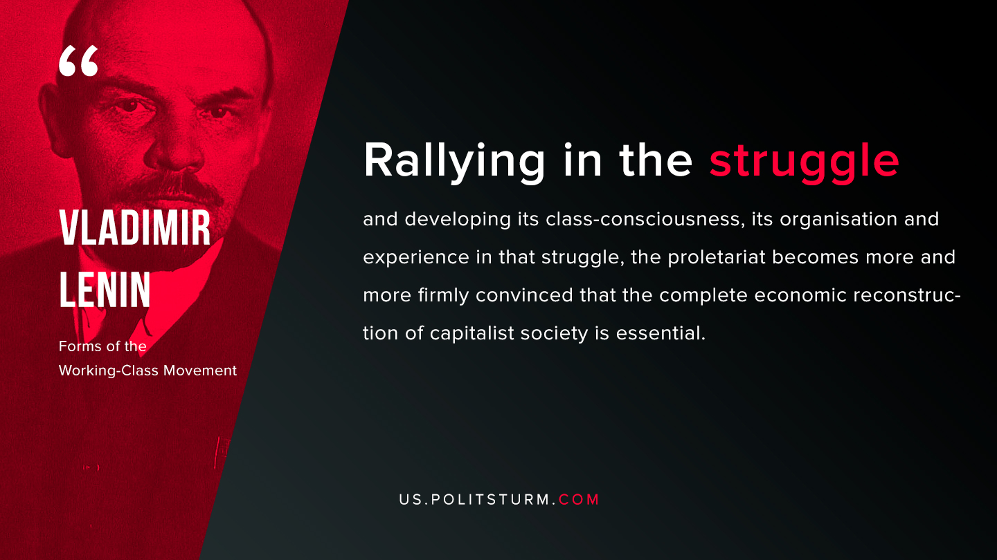

Original article
2019-08-02

Rallying in the struggle and developing its class-consciousness, its organisation and experience in that struggle, the proletariat becomes more and more firmly convinced that the complete economic reconstruction of capitalist society is essential.
V.I. Lenin “Forms of the Working-Class Movement”

Original article

