Lenin on the Oppression of Capital
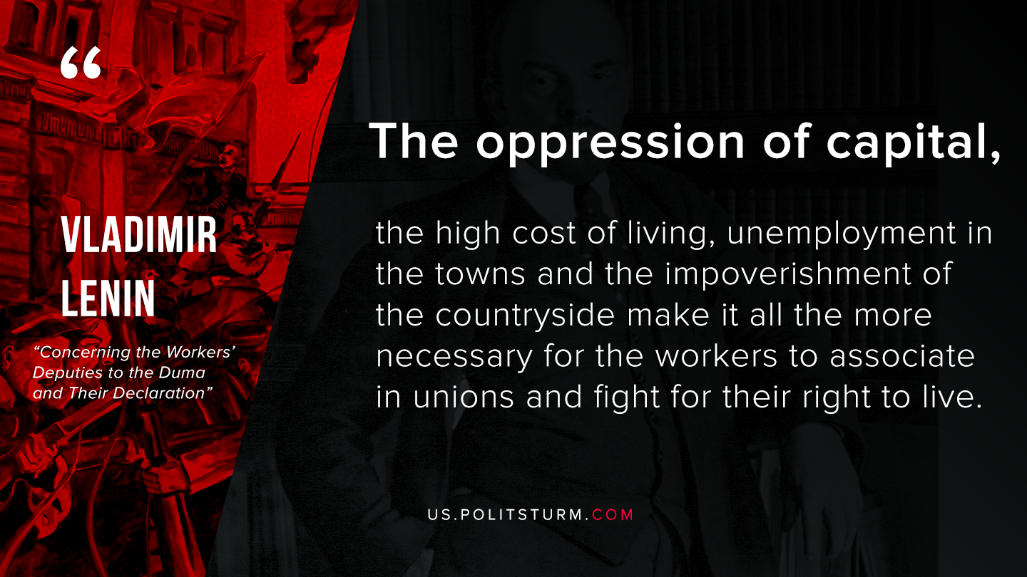

Original article
2020-04-08

The oppression of capital, the high cost of living, unemployment in the towns and the impoverishment of the countryside
make it all the more necessary for the workers to associate in unions and fight for their right to live.
Lenin, Concerning the Workers’ Deputies to the Duma and Their Declaration

Original article

