Lenin on the Oppressed Classes
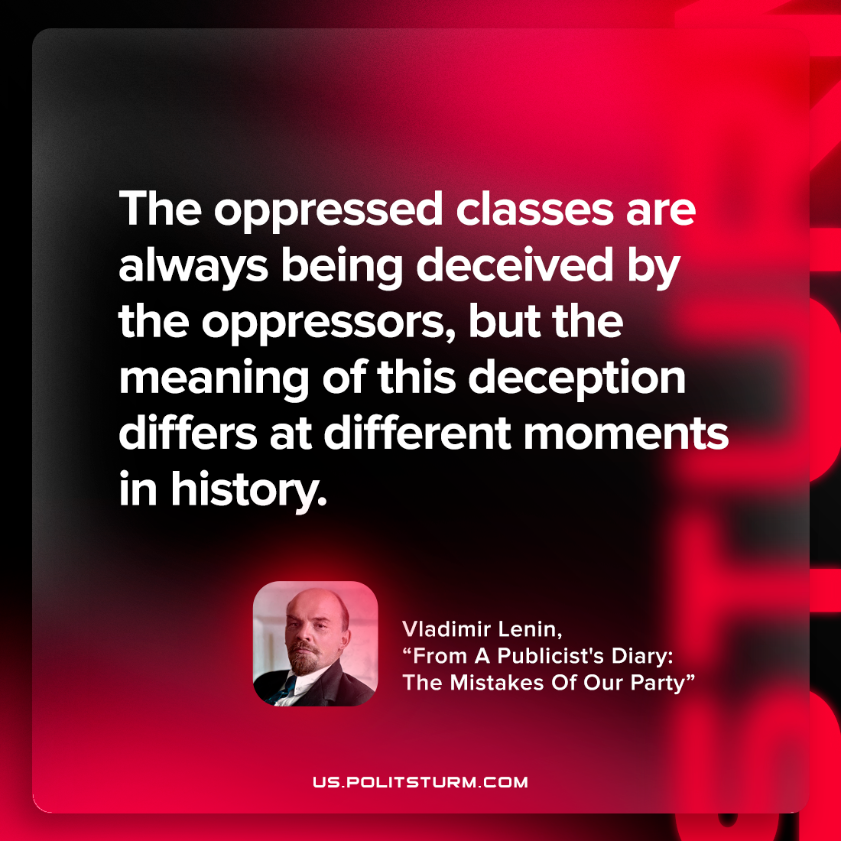

Original article
2022-08-20

The oppressed classes are always being deceived by the oppressors, but the meaning of this deception differs at different moments in history.

Vladimir Lenin, “From A Publicist’s Diary: The Mistakes Of Our Party”

Original article

