Lenin on the Only Way Capitalism Can be Overthrown
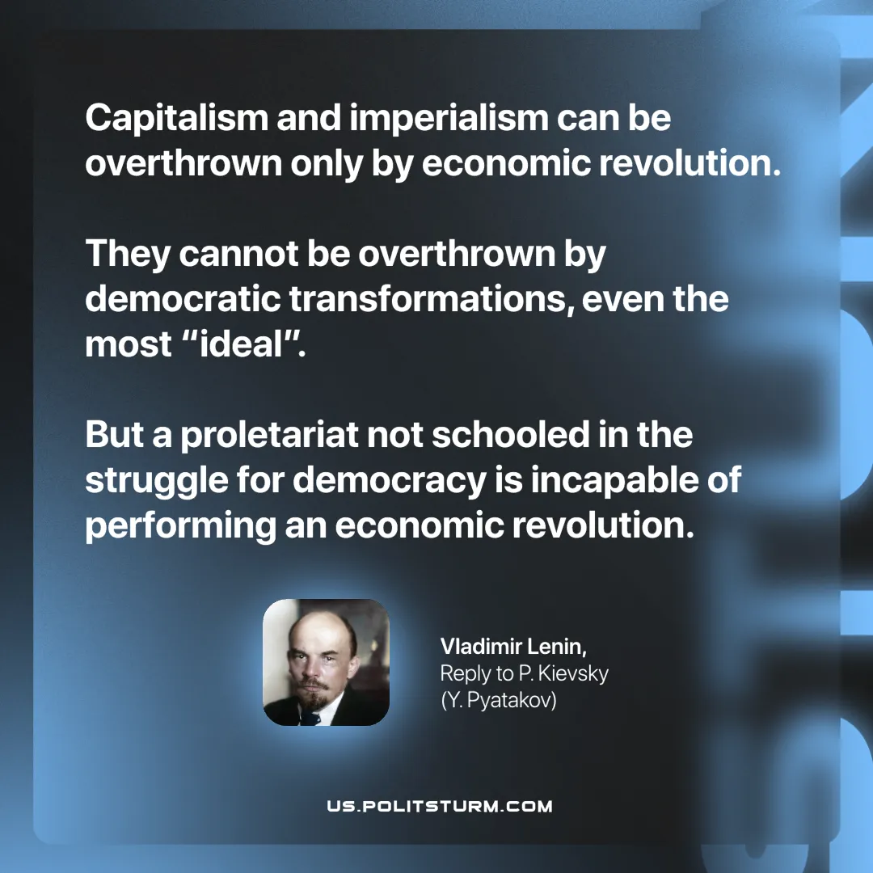

Original article
2025-06-28

“Capitalism and imperialism can be overthrown only by economic revolution. They cannot be overthrown by democratic transformations, even the most “ideal”. But a proletariat not schooled in the struggle for democracy is incapable of performing an economic revolution.”
Vladimir Lenin, Reply to P. Kievsky (Y. Pyatakov)

Original article

