Lenin on the Need for a Proletarian Revolution in an Imperialist War
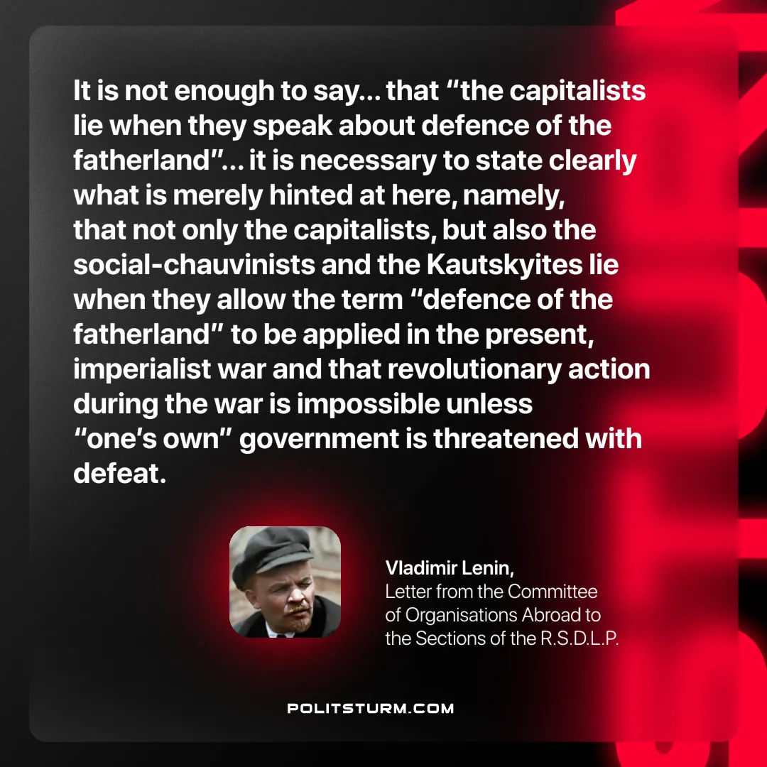

Original article
2025-06-12
1 min read

“It is not enough to say… that “the capitalists lie when they speak about defence of the fatherland” in the present war… it is necessary to state clearly what is merely hinted at here, namely, that not only the capitalists, but also the social-chauvinists and the Kautskyites lie when they allow the term “defence of the fatherland” to be applied in the present, imperialist war and that revolutionary action during the war is impossible unless “one’s own” government is threatened with defeat."
Vladimir Lenin, Letter from the Committee of Organisations Abroad to the Sections of the R.S.D.L.P.

Original article

