Lenin on the Necessity of Strikes
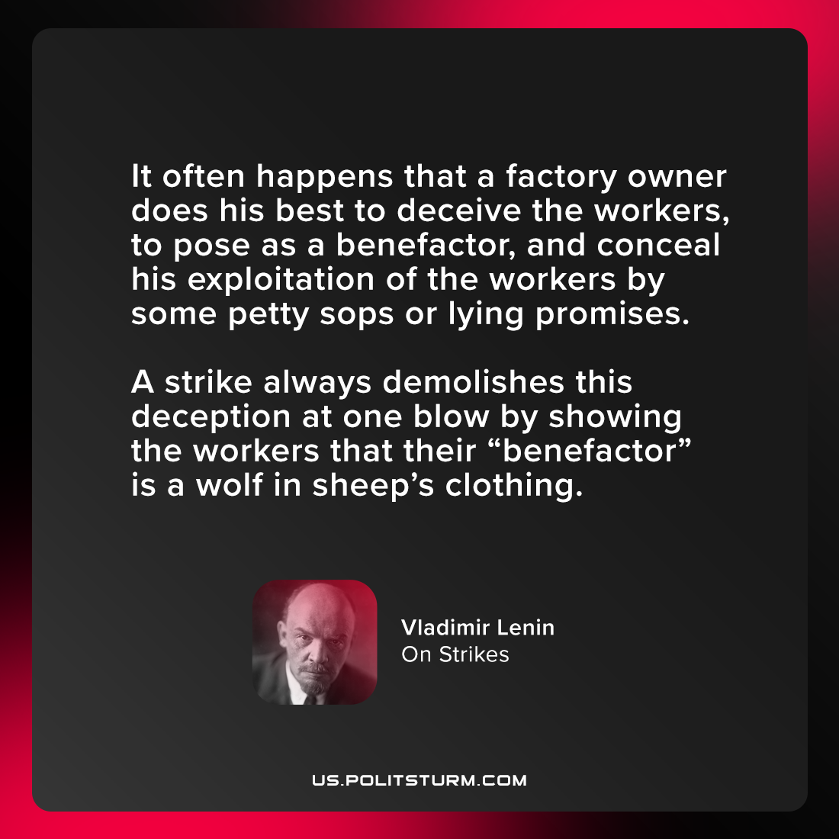

Original article
2021-08-05

It often happens that a factory owner does his best to deceive the workers, to pose as a benefactor, and conceal his exploitation of the workers by some petty sops or lying promises. A strike always demolishes this deception at one blow by showing the workers that their “benefactor” is a wolf in sheep’s clothing.

Vladimir Lenin, “On Strikes”

Original article

