Lenin on Nationalism
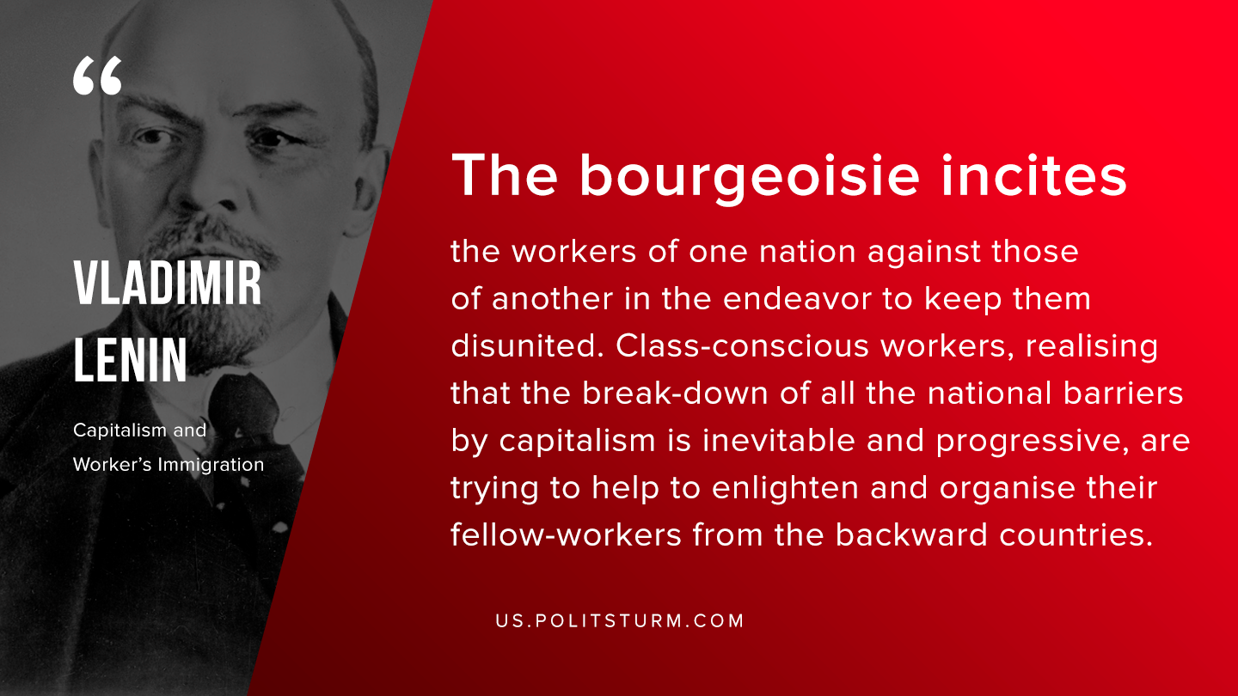

Original article
2019-09-26

The bourgeoisie incites the workers of one nation against those of another in the endeavor to keep them disunited. Class-conscious workers, realising that the break-down of all the national barriers by capitalism is inevitable and progressive, are trying to help to enlighten and organise their fellow-workers from the backward countries.
Vladimir Lenin, “Capitalism and Workers’ Immigration”

Original article

