Lenin on the Limitations of Terror as a Strategy
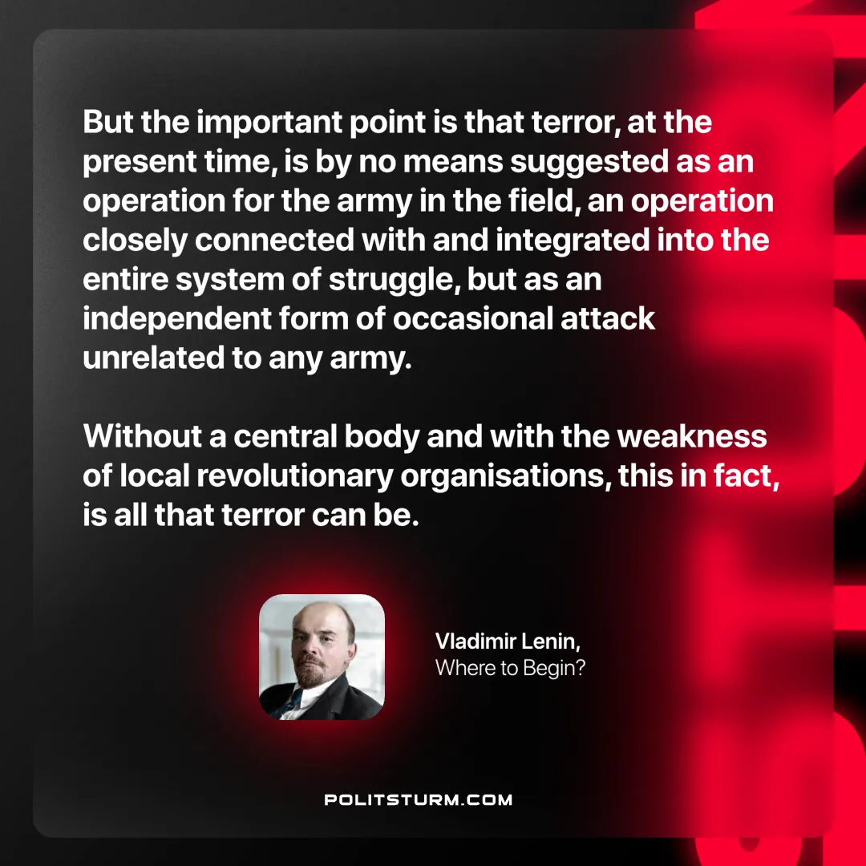

Original article
2024-12-28

“But the important point is that terror, at the present time, is by no means suggested as an operation for the army in the field, an operation closely connected with and integrated into the entire system of struggle, but as an independent form of occasional attack unrelated to any army. Without a central body and with the weakness of local revolutionary organisations, this, in fact, is all that terror can be.”
Vladimir Lenin, Where to Begin?

Original article

