Lenin on the liberal bourgeoisie
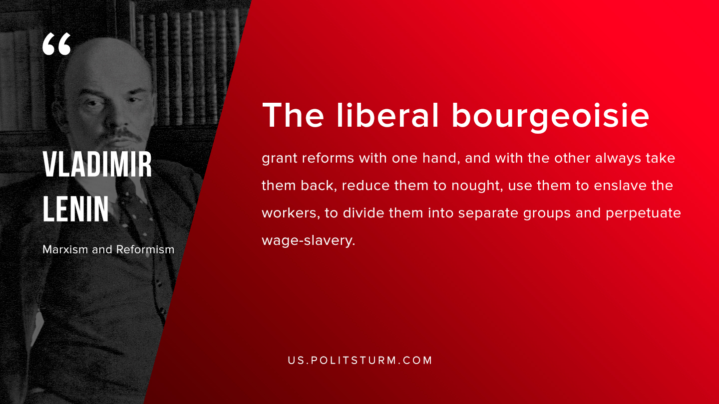

Original article
2019-07-31

The liberal bourgeoisie grant reforms with one hand, and with the other always take them back, reduce them to nought, use them to enslave the workers, to divide them into separate groups and perpetuate wage-slavery.
V.I. Lenin, “Marxism and Reformism”

Original article

