Lenin on the Labor Aristocracy
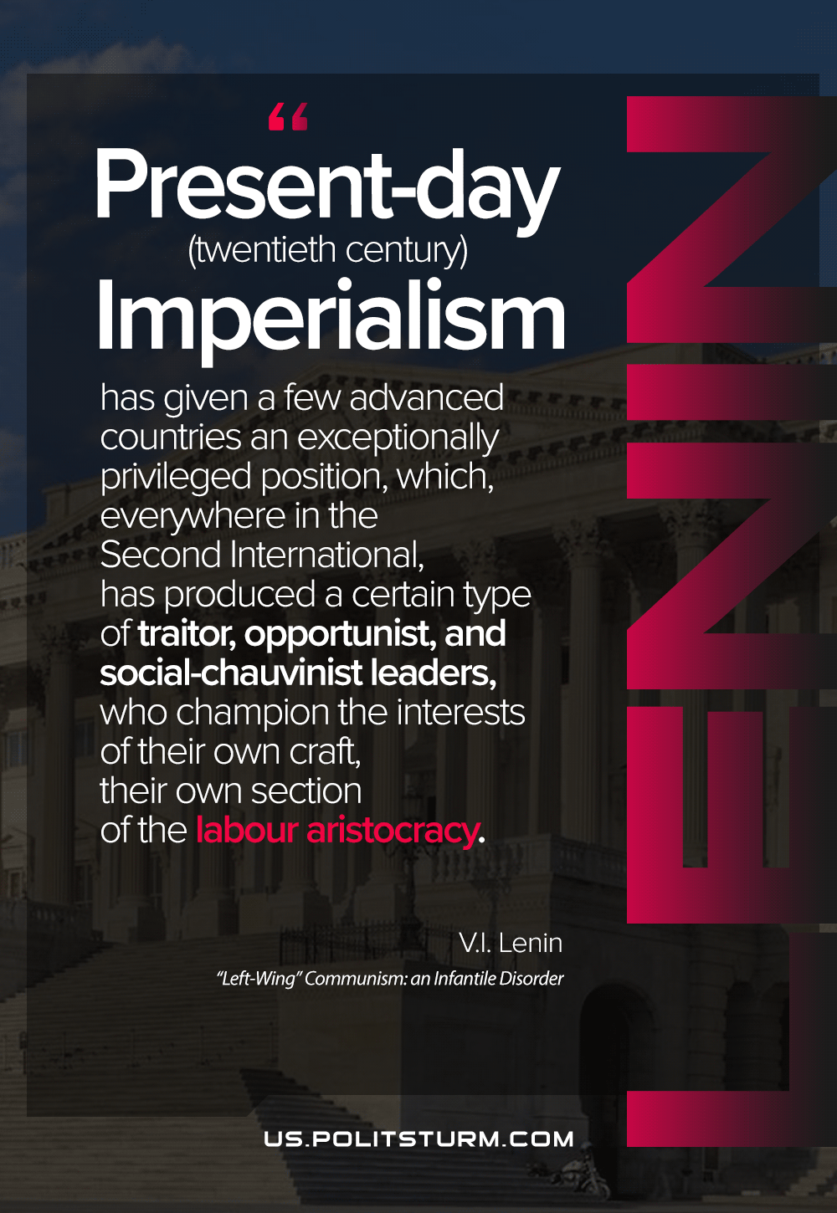

Original article
2021-04-13

Present-day (twentieth-century) imperialism has given a few advanced countries an exceptionally privileged position, which, everywhere in the Second International, has produced a certain type of traitor, opportunist, and social-chauvinist leaders, who champion the interests of their own craft, their own section of the labour aristocracy.
Vladimir Lenin, “Left-Wing” Communism: an Infantile Disorder

Original article

