Lenin on the "Internationalism" of Opportunists and Nationalists
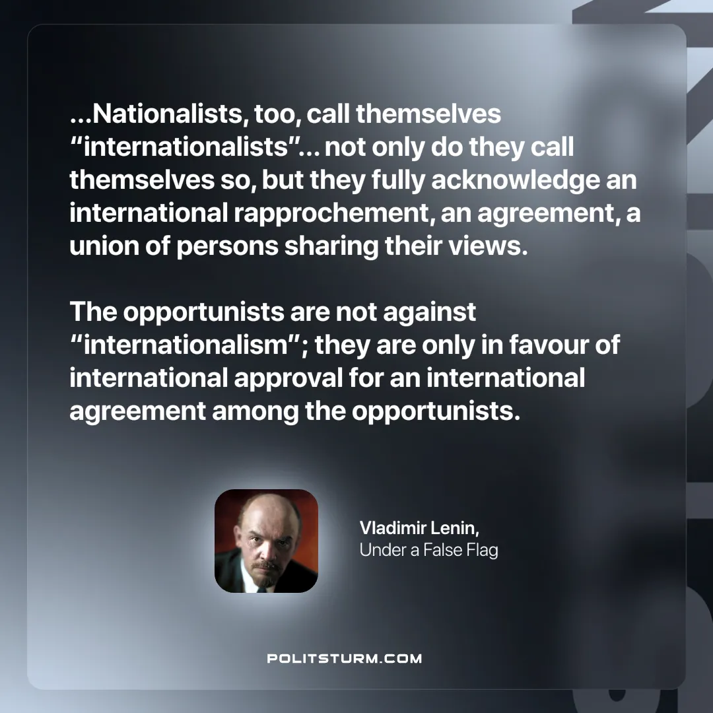

Original article
2025-04-17

“...Nationalists, too, call themselves “internationalists”... not only do they call themselves so, but they fully acknowledge an international rapprochement, an agreement, a union of persons sharing their views. The opportunists are not against “internationalism”; they are only in favour of international approval for an international agreement among the opportunists."
Vladimir Lenin, Under a False Flag

Original article

