Lenin on the International Revolutionary Movement
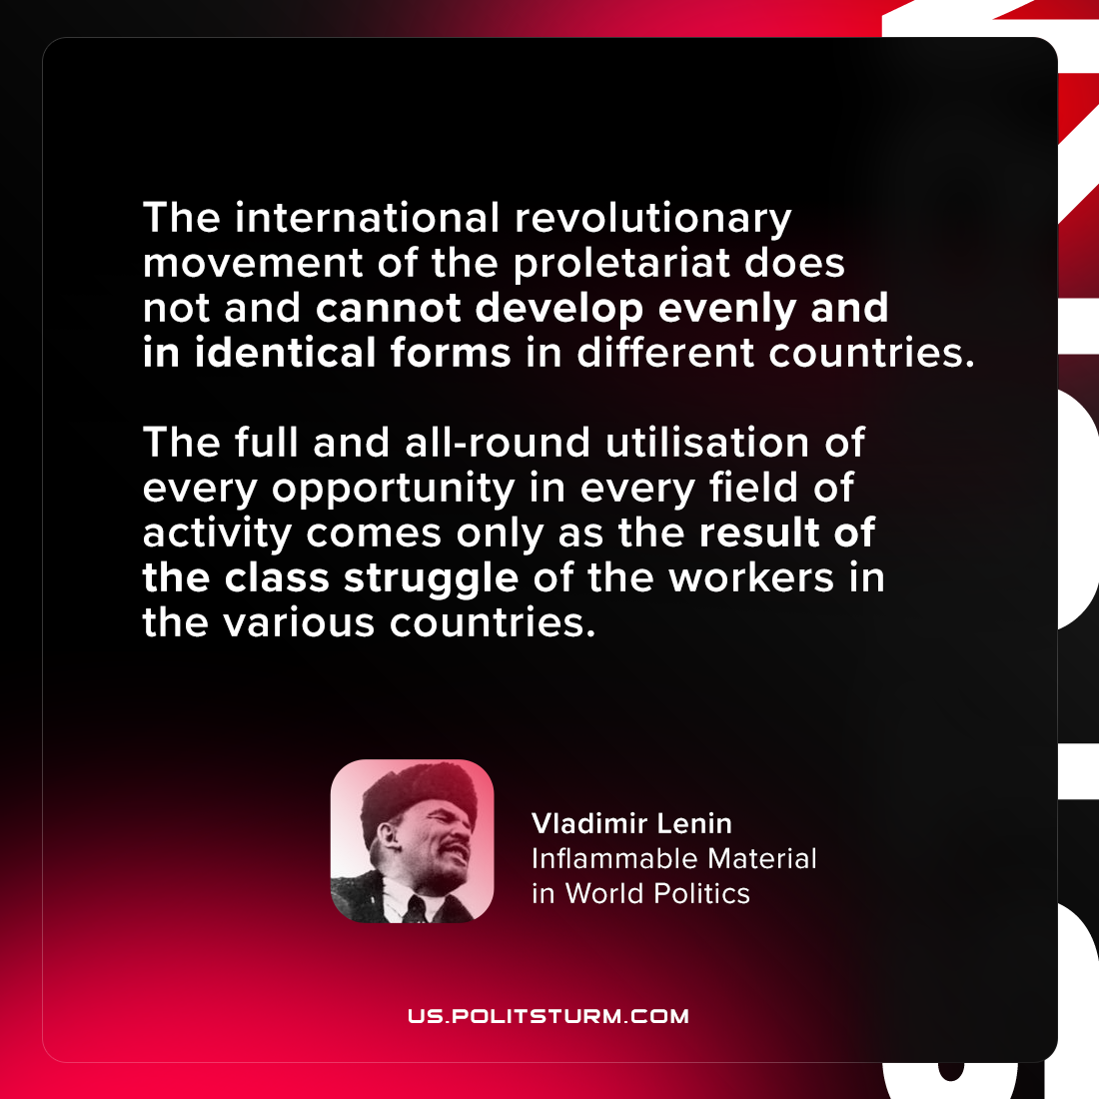

Original article
2021-07-16

The international revolutionary movement of the proletariat does not and cannot develop evenly and in identical forms in different countries. The full and all-round utilisation of every opportunity in every field of activity comes only as the result of the class struggle of the workers in the various countries.

Vladimir Lenin, “Inflammable Material in World Politics”

Original article

