Lenin on the International Culture of the Workers
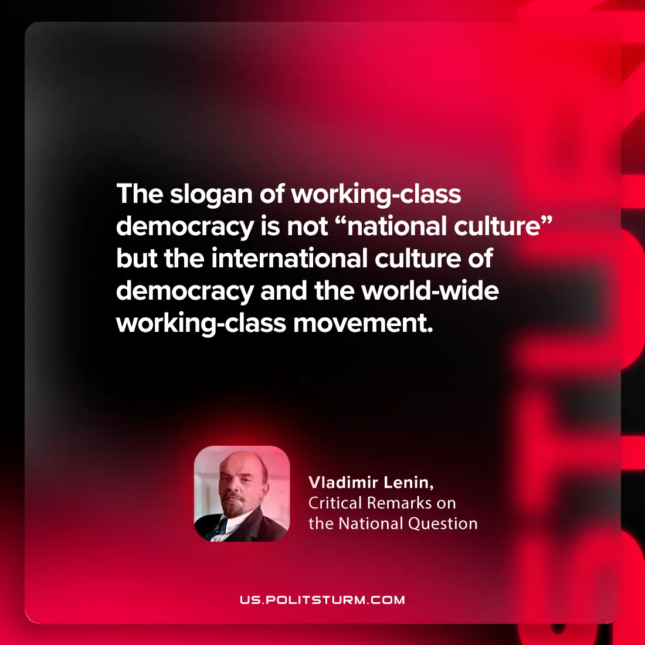

Original article
2024-08-27

"The slogan of working-class democracy is not “national culture” but the international culture of democracy and the world-wide working-class movement.”
Vladimir Lenin, Critical Remarks on the National Question

Original article

