Lenin on the Intensification of Finance Capital Dividing the World
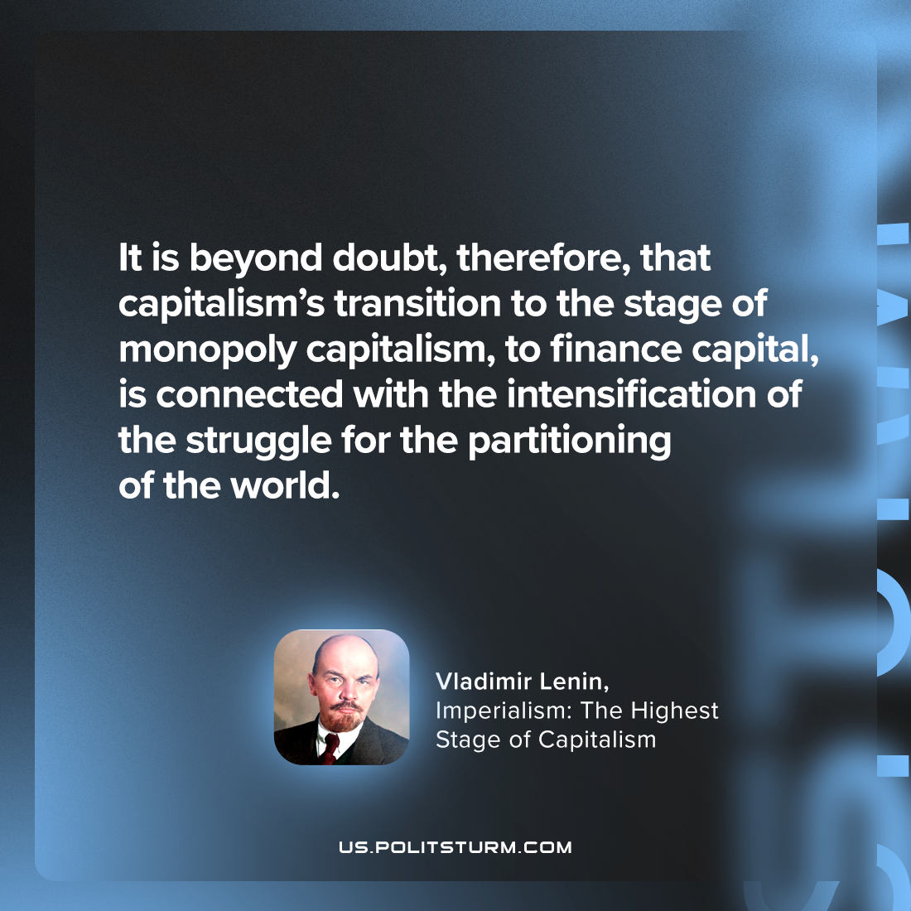

Original article
2024-06-23

"It is beyond doubt, therefore, that capitalism’s transition to the stage of monopoly capitalism, to finance capital, is connected with the intensification of the struggle for the partitioning of the world."
Vladimir Lenin, Imperialism: The Highest Stage of Capitalism

Original article

