Lenin on the Intellectuals
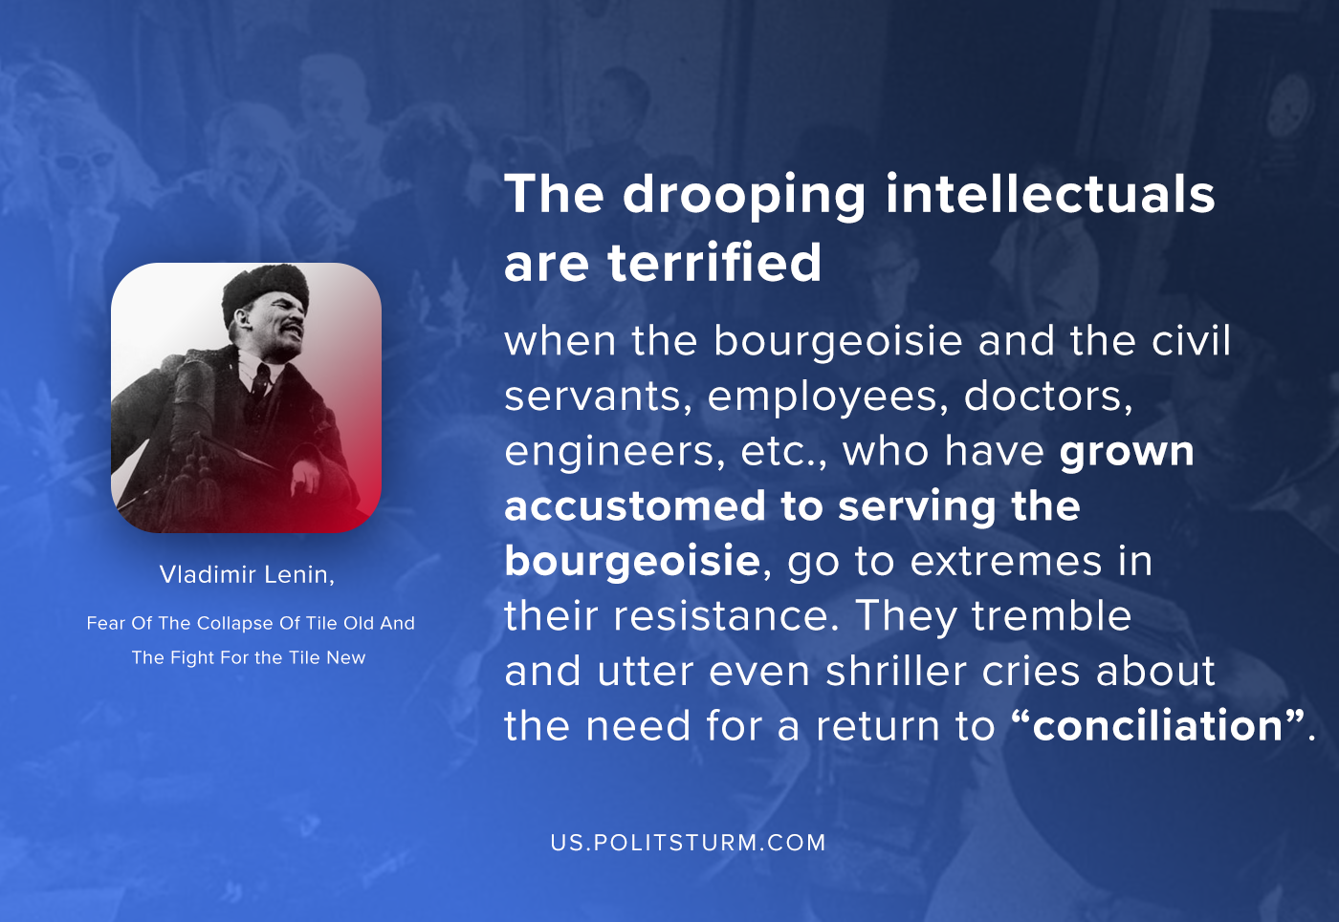

Original article
2020-10-06
1 min read

The drooping intellectuals are terrified when the bourgeoisie and the civil servants, employees, doctors, engineers, etc., who have grown accustomed to serving the bourgeoisie, go to extremes in their resistance. They tremble and utter even shriller cries about the need for a return to “conciliation”. Like all true friends of the oppressed class, we can only derive satisfaction from the exploiters’ extreme measures of resistance, because we do not expect the proletariat to mature for power in an atmosphere of cajoling and persuasion, in a school of mealy sermons or didactic declamations, but in the school of life and struggle. To become the ruling class and defeat the bourgeoisie for good the proletariat must be schooled, because the skill this implies does not come ready-made.
Vladimir Lenin, Fear Of The Collapse Of Tile Old And The Fight For Tile New.

Original article

