Lenin on the Imperialist World
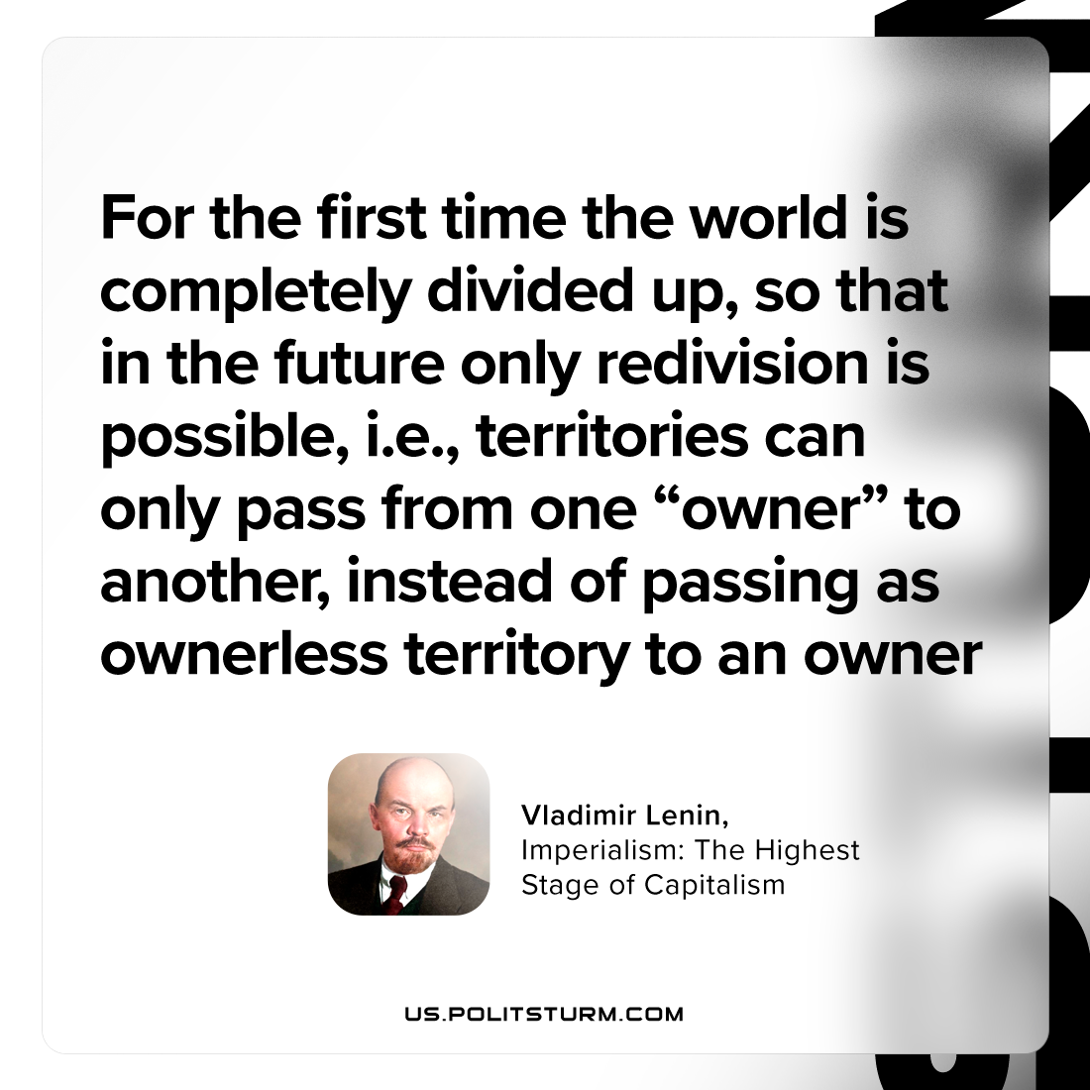

Original article
2023-12-23

"For the first time the world is completely divided up, so that in the future only redivision is possible, i.e., territories can only pass from one “owner” to another, instead of passing as ownerless territory to an owner"
Vladimir Lenin, Imperialism: the Highest Stage of Capitalism

Original article

