Lenin on the Hypocrisy of Capitalist Production
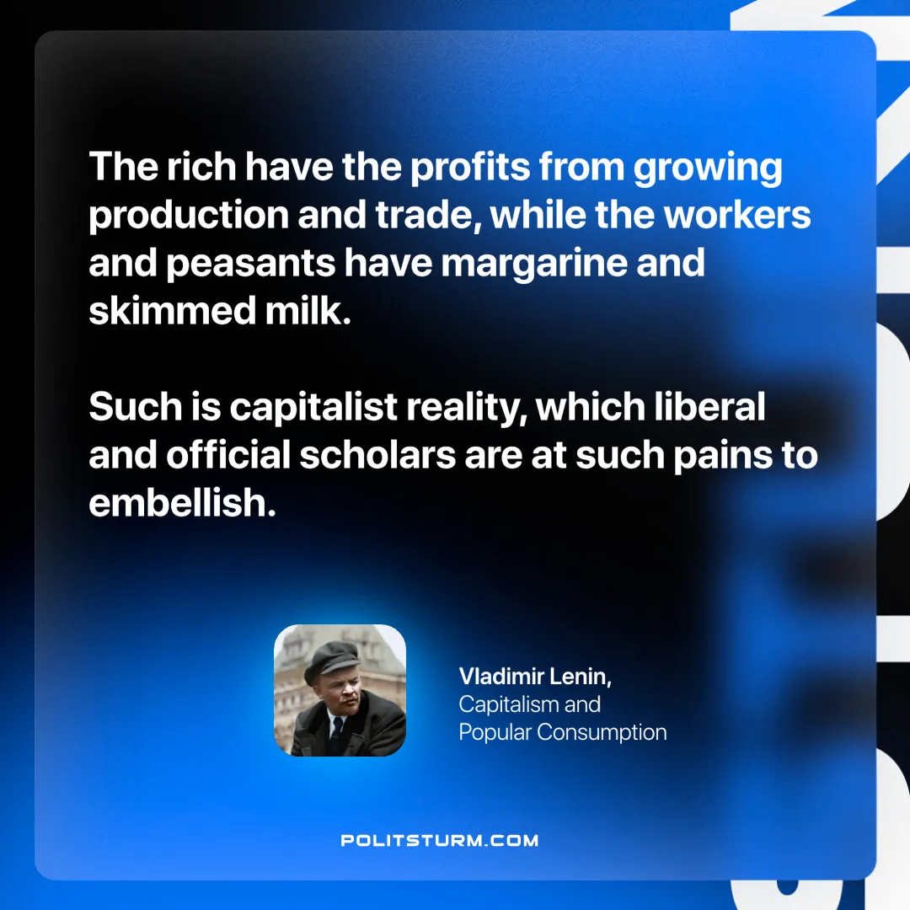

Original article
2025-04-03

"The rich have the profits from growing production and trade, while the workers and peasants have margarine and skimmed milk. Such is capitalist reality, which liberal and official scholars are at such pains to embellish."
Vladimir Lenin, Capitalism and Popular Consumption

Original article

