Lenin on the History of the Rise of Finance Capital
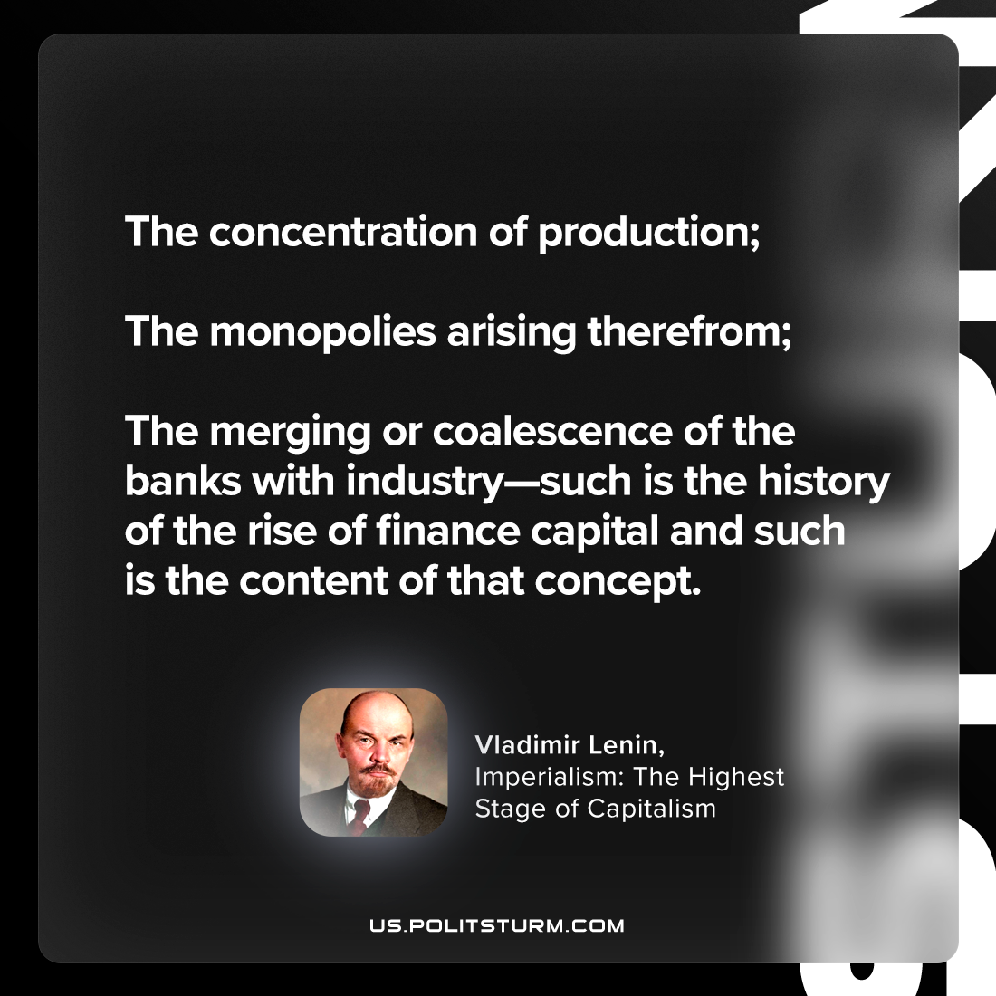

Original article
2023-09-28

"The concentration of production; the monopolies arising therefrom; the merging or coalescence of the banks with industry—such is the history of the rise of finance capital and such is the content of that concept."
Vladimir Lenin, Imperialism: the Highest Stage of Capitalism

Original article

