Lenin on the History of Class Struggle
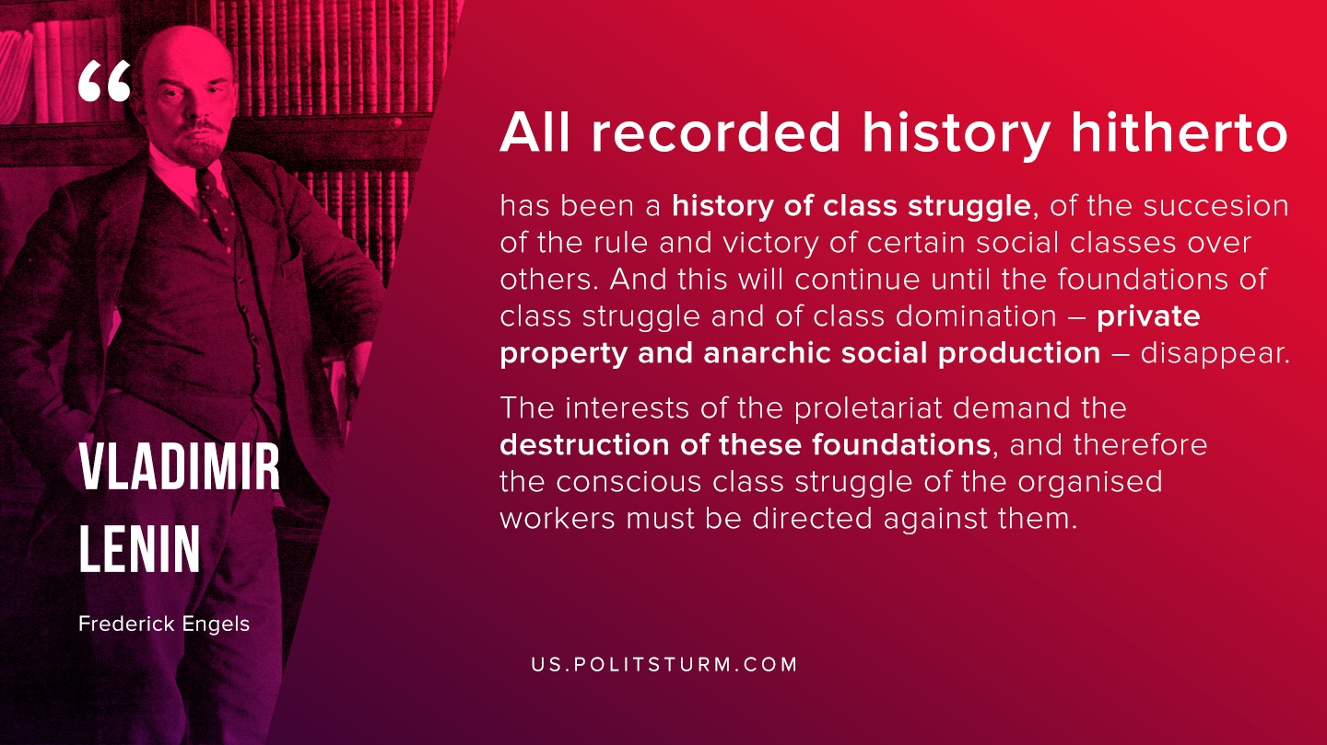

Original article
2020-06-23

All recorded history hitherto has been a history of class struggle, of the succession of the rule and victory of certain social classes over others. And this will continue until the foundations of class struggle and of class domination – private property and anarchic social production – disappear. The interests of the proletariat demand the destruction of these foundations, and therefore the conscious class struggle of the organised workers must be directed against them.
Vladimir Lenin, “Frederick Engels”

Original article

