Lenin on the Highest Form of Capitalism
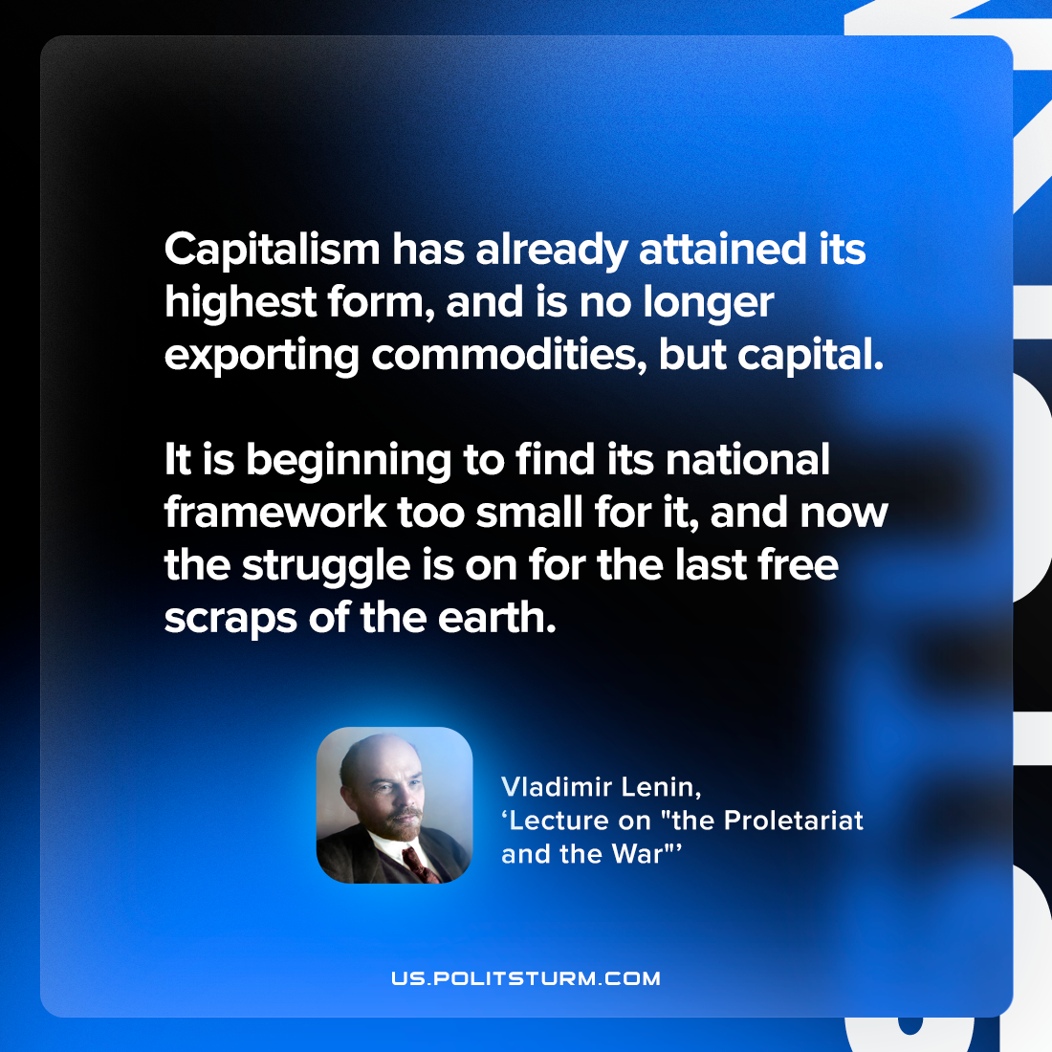

Original article
2023-02-12

"Capitalism has already attained its highest form, and is no longer exporting commodities, but capital. It is beginning to find its national framework too small for it, and now the struggle is on for the last free scraps of the earth."
Vladimir Lenin, “Lecture on "the Proletariat and the War"”

Original article

