Lenin On The Hatred Of The Bourgeoisie
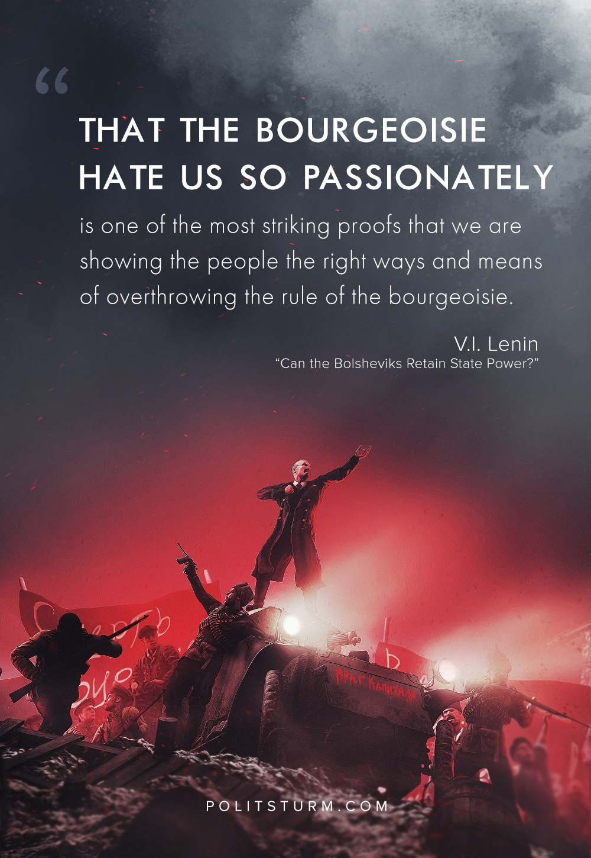

Original article
2018-08-09

“That the bourgeoisie hate us so passionately is one of the most striking proofs that we are showing the people the right ways and means of overthrowing the rule of the bourgeoisie. ”
V.I. Lenin, “Can the Bolsheviks Retain State Power?”

Original article

