Lenin on the Fight Against Imperialism and Opportunism
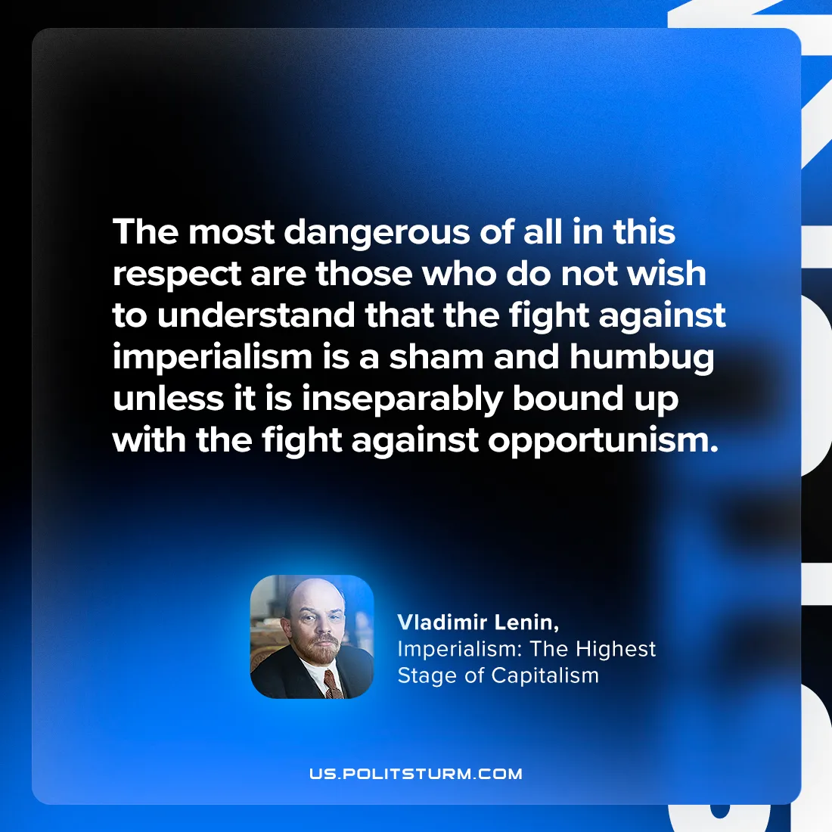

Original article
2024-08-22

"The most dangerous of all in this respect are those who do not wish to understand that the fight against imperialism is a sham and humbug unless it is inseparably bound up with the fight against opportunism.”
Vladimir Lenin, Imperialism: The Highest Stage of Capitalism

Original article

