Lenin on the Feature of Imperialism
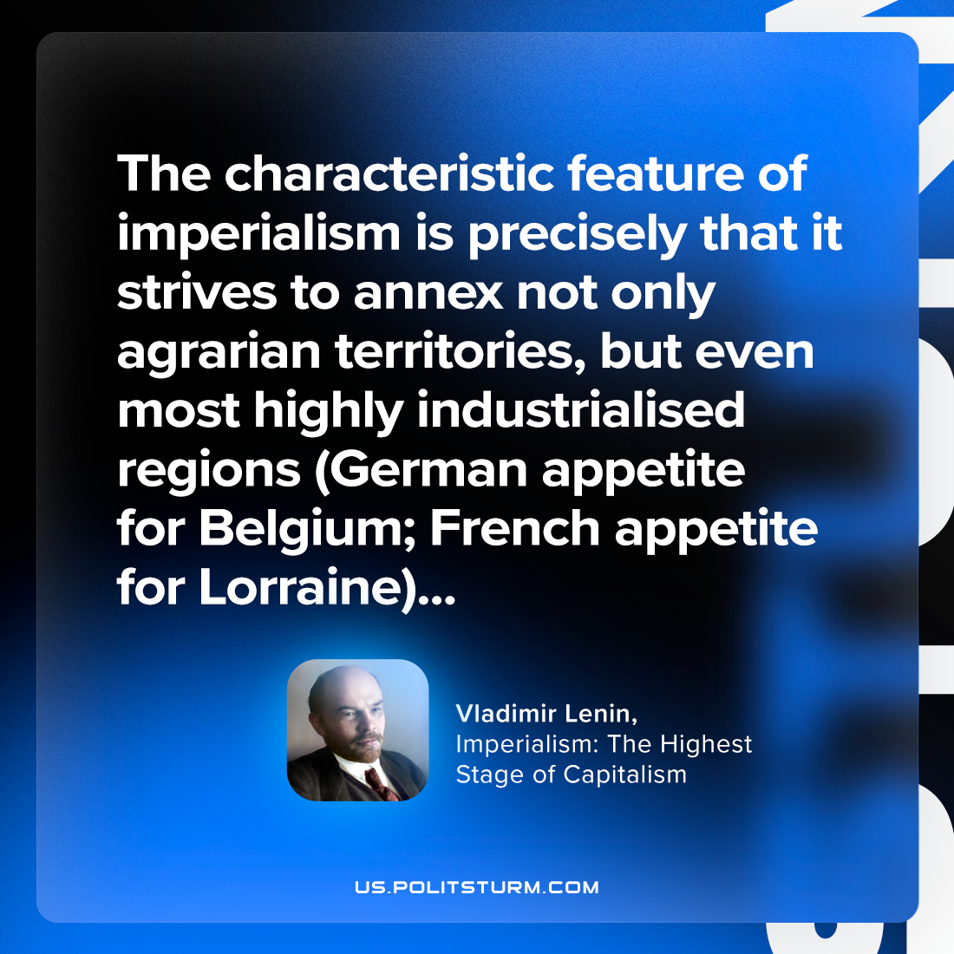

Original article
2023-11-19

"The characteristic feature of imperialism is precisely that it strives to annex not only agrarian territories, but even most highly industrialised regions (German appetite for Belgium; French appetite for Lorraine)..."
Vladimir Lenin, Imperialism: the Highest Stage of Capitalism

Original article

