Lenin on the Fate of Capitalism
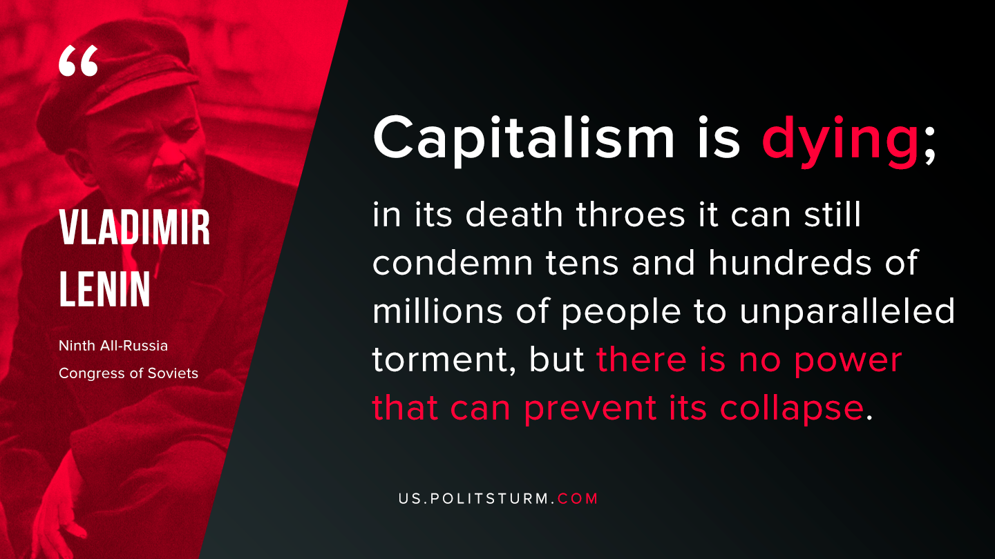

Original article
2019-10-01

Capitalism is dying; in its death throes it can still condemn tens and hundreds of millions of people to unparalleled torment, but there is no power that can prevent its collapse.
Vladimir Lenin, “Ninth All-Russia Congress of Soviets”

Original article

