Lenin on the Export of Capital
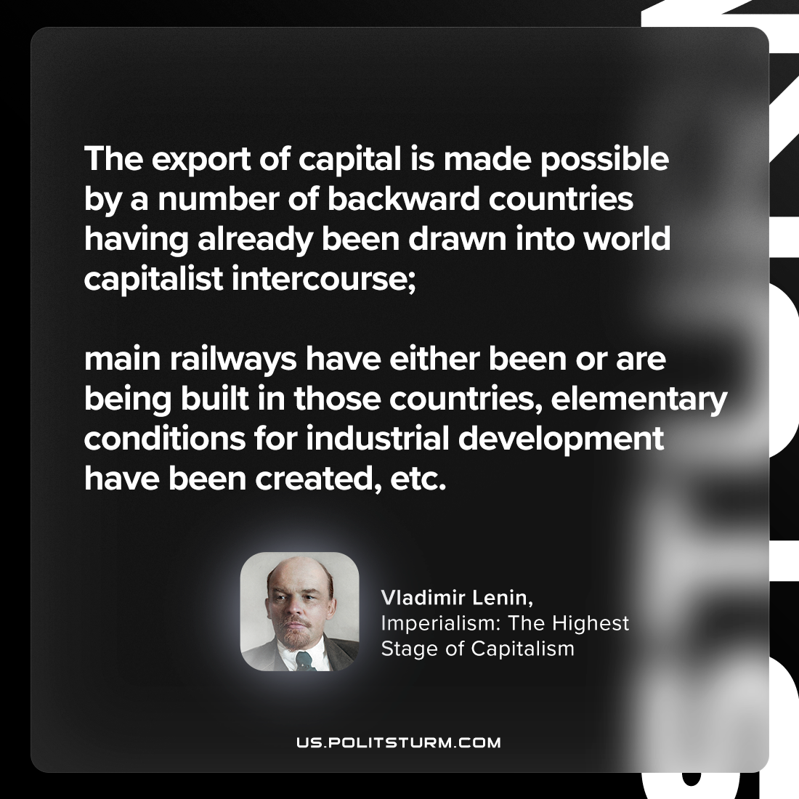

Original article
2023-10-26

"The export of capital is made possible by a number of backward countries having already been drawn into world capitalist intercourse; main railways have either been or are being built in those countries, elementary conditions for industrial development have been created, etc."
Vladimir Lenin, Imperialism: the Highest Stage of Capitalism

Original article

