Lenin on the Essence of the Communist Party
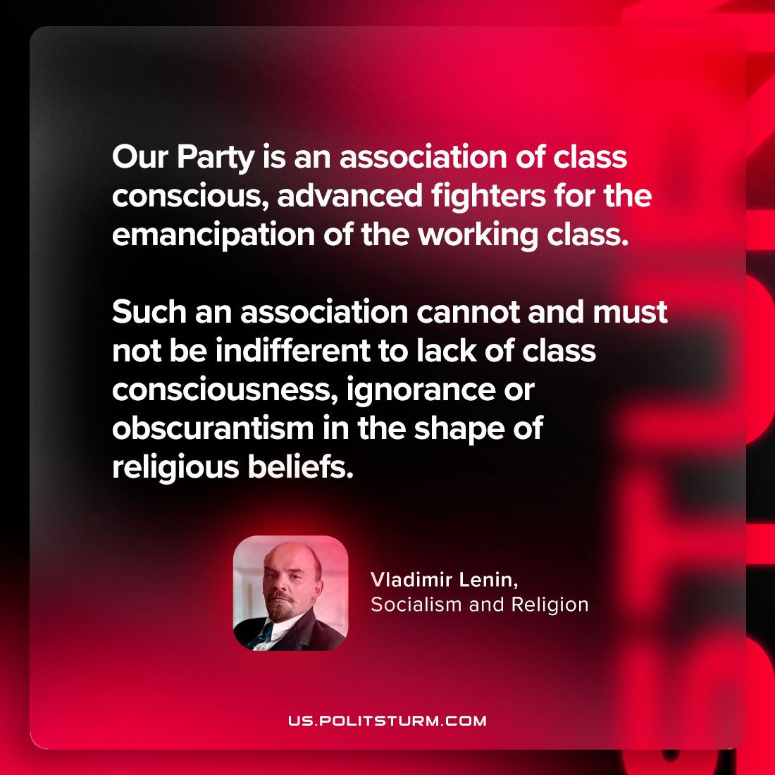

Original article
2024-05-04

“Our Party is an association of class-conscious, advanced fighters for the emancipation of the working class. Such an association cannot and must not be indifferent to lack of class-consciousness, ignorance or obscurantism in the shape of religious beliefs.”
Vladimir Lenin, Socialism and Religion

Original article

