Lenin on the Epoch of the Latest Stage of Capitalism
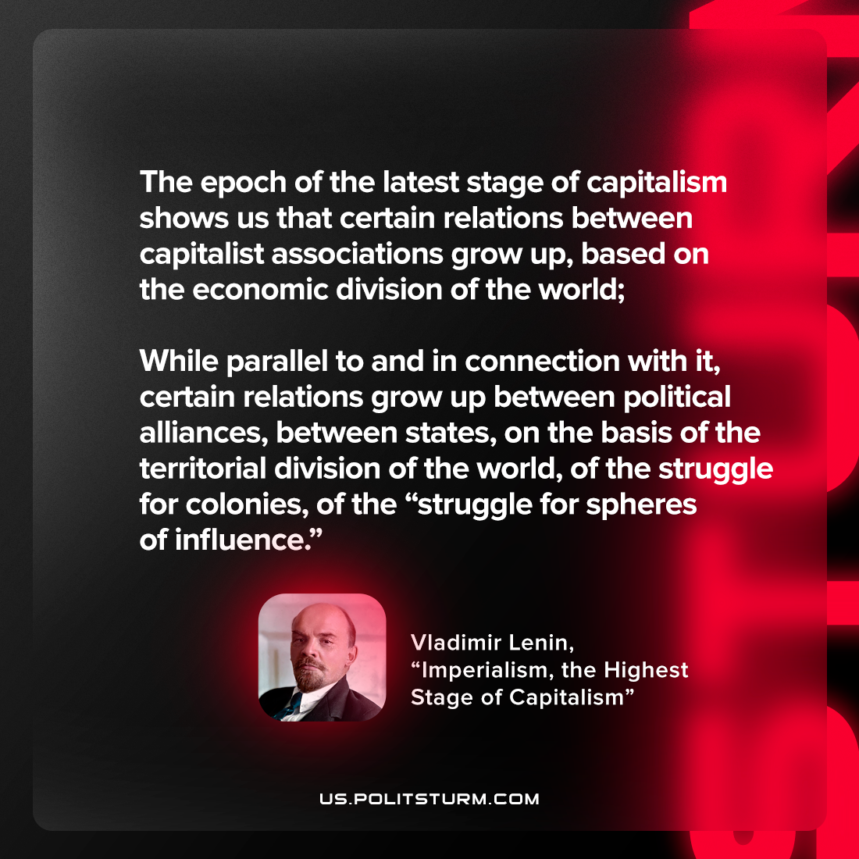

Original article
2023-02-26

"The epoch of the latest stage of capitalism shows us that certain relations between capitalist associations grow up, based on the economic division of the world; while parallel to and in connection with it, certain relations grow up between political alliances, between states, on the basis of the territorial division of the world, of the struggle for colonies, of the “struggle for spheres of influence.”"
Vladimir Lenin, “Imperialism: the Highest Stage of Capitalism”

Original article

