Lenin on the Epoch of Imperialism and Revolutionary Vanguard
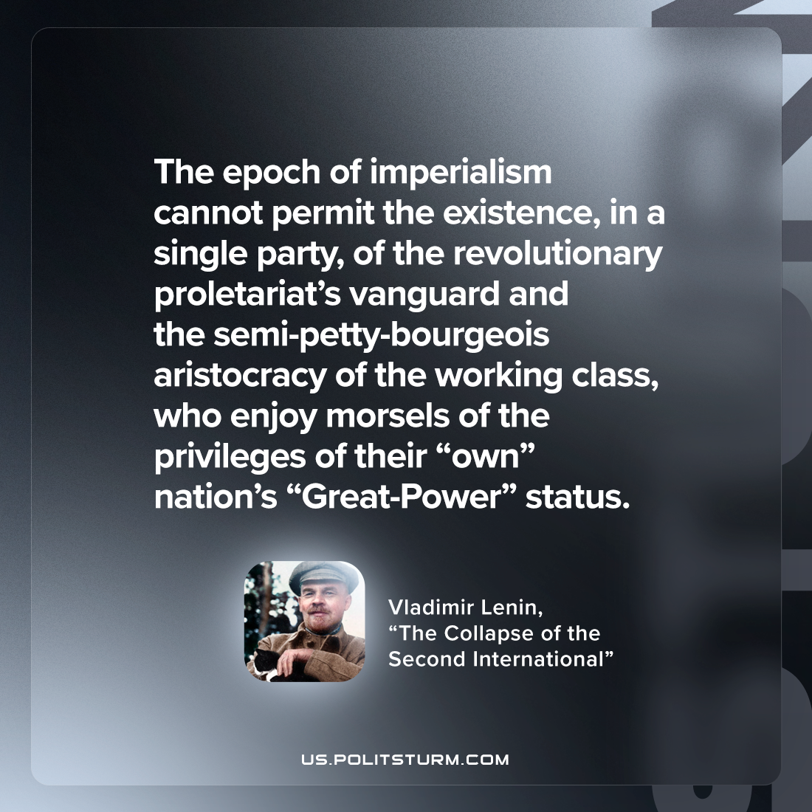

Original article
2022-12-31

"The epoch of imperialism cannot permit the existence, in a single party, of the revolutionary proletariat’s vanguard and the semi-petty-bourgeois aristocracy of the working class, who enjoy morsels of the privileges of their “own” nation’s “Great-Power” status."
Vladimir Lenin, “The Collapse of the Second International”

Original article

