Lenin on the Domination of Capitalist Ideology on the Movement
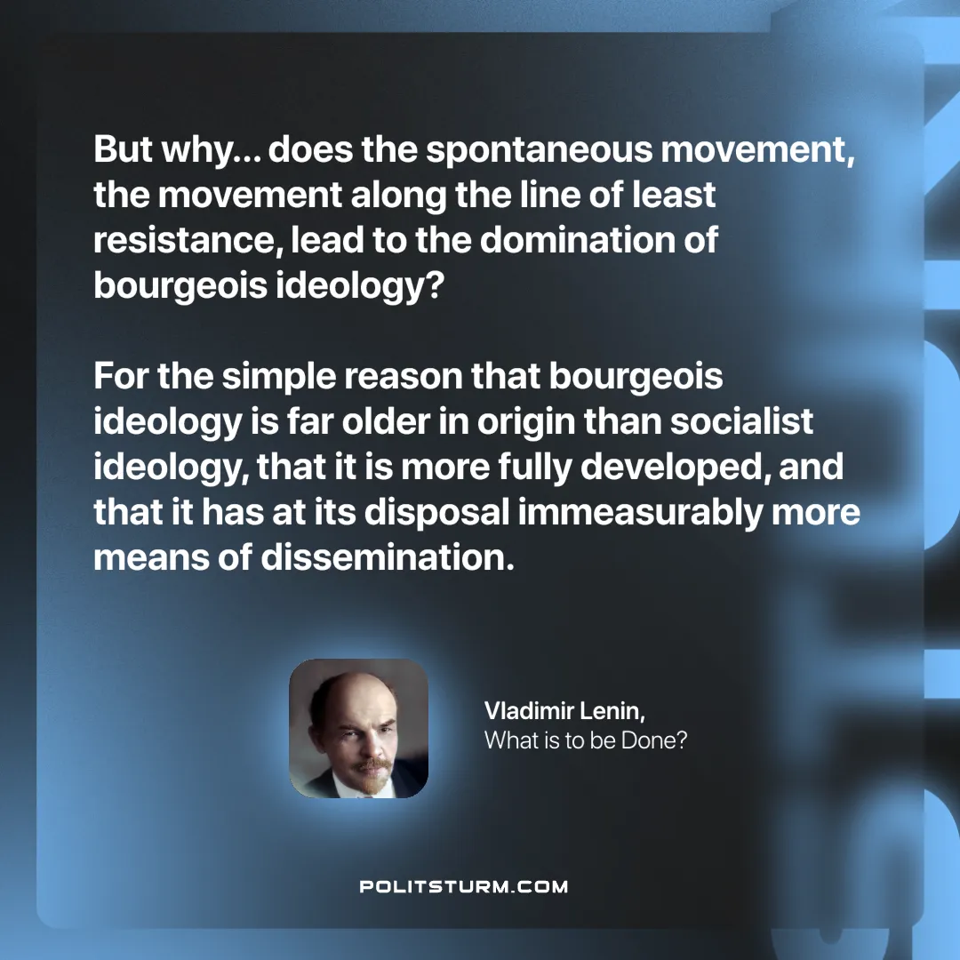

Original article
2025-01-12

“But why… does the spontaneous movement, the movement along the line of least resistance, lead to the domination of bourgeois ideology? For the simple reason that bourgeois ideology is far older in origin than socialist ideology, that it is more fully developed, and that it has at its disposal immeasurably more means of dissemination.”
Vladimir Lenin, What is to be Done?

Original article

