Lenin on the Division of the World
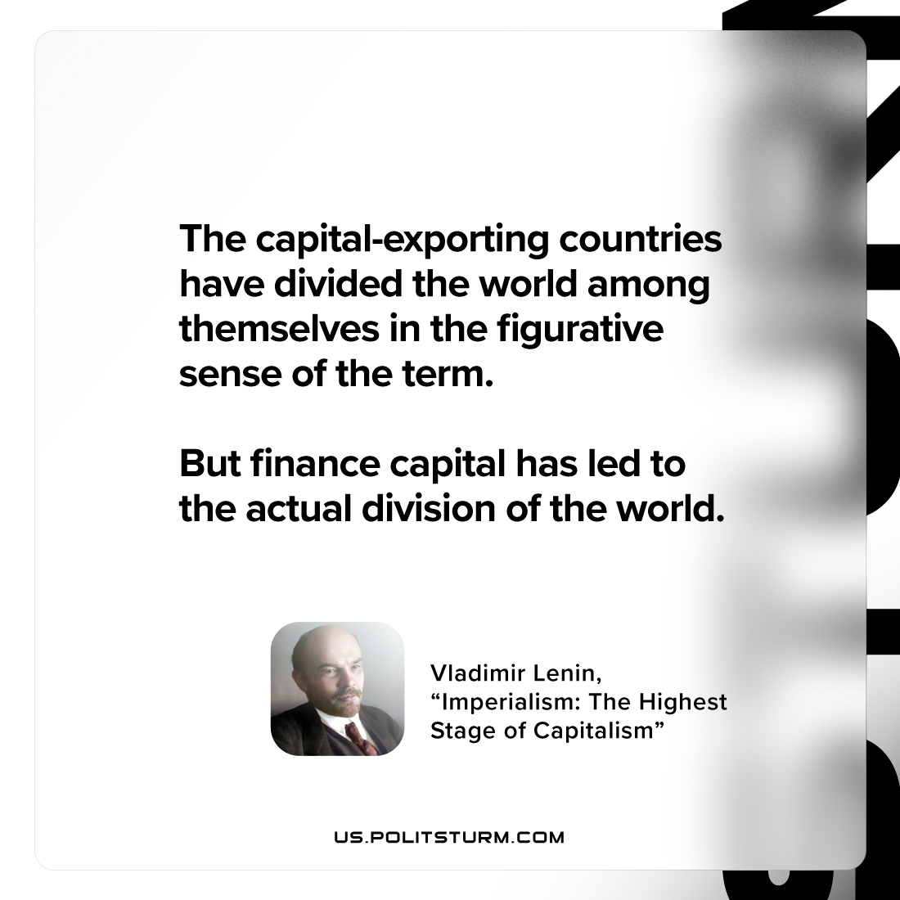

Original article
2023-01-26

"The capital-exporting countries have divided the world among themselves in the figurative sense of the term. But finance capital has led to the actual division of the world."
Vladimir Lenin, “Imperialism: the Highest Stage of Capitalism”

Original article

