Lenin on the Deviations From Proletarian Policy in the National Question
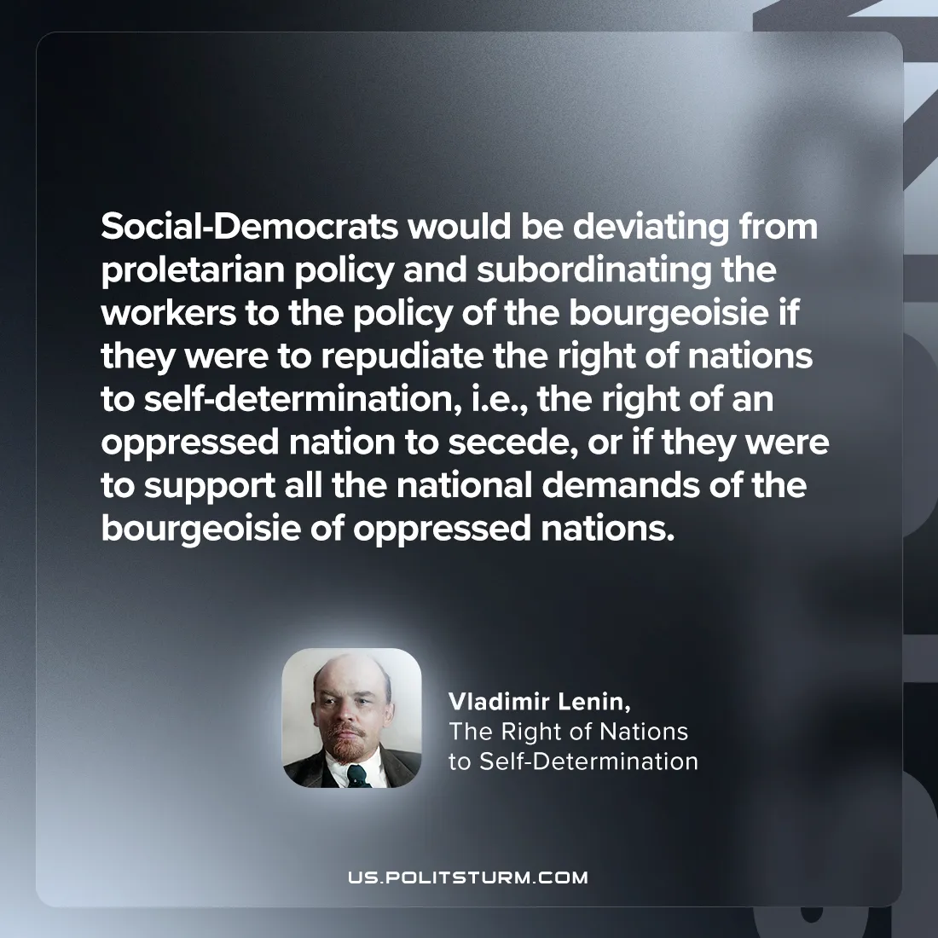

Original article
2024-09-29

“Social-Democrats would be deviating from proletarian policy and subordinating the workers to the policy of the bourgeoisie if they were to repudiate the right of nations to self-determination, i.e., the right of an oppressed nation to secede, or if they were to support all the national demands of the bourgeoisie of oppressed nations.”
Vladimir Lenin, The Right of Nations to Self-determination

Original article

