Lenin on the Democratic Loopholes Towards Dictatorship
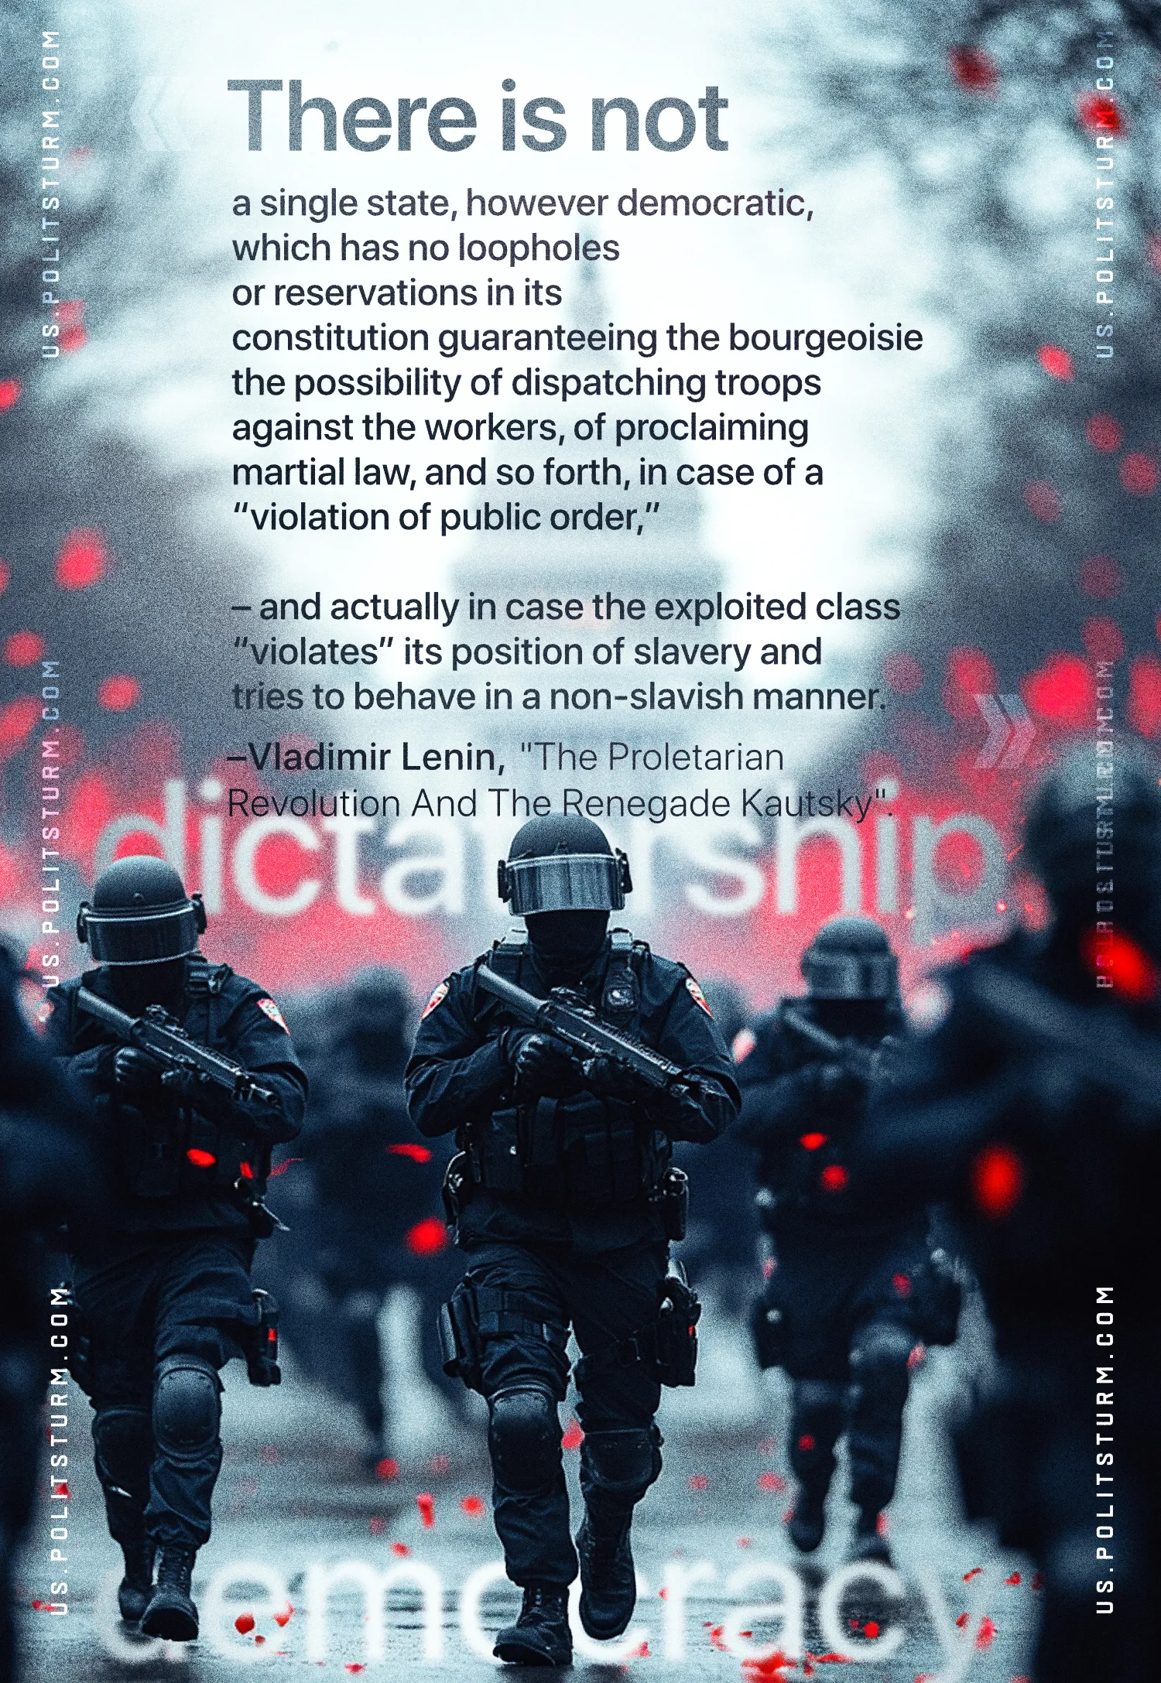

Original article
2025-02-09

"There is not a single state, however democratic, which has no loopholes or reservations in its constitution guaranteeing the bourgeoisie the possibility of dispatching troops against the workers, of proclaiming martial law, and so forth, in case of a “violation of public order,” and actually in case the exploited class “violates” its position of slavery and tries to behave in a non-slavish manner."
Vladimir Lenin, The Proletarian Revolution And The Renegade Kautsky

Original article

