Lenin on the Contradictions of Capitalism in the Era of Imperialism
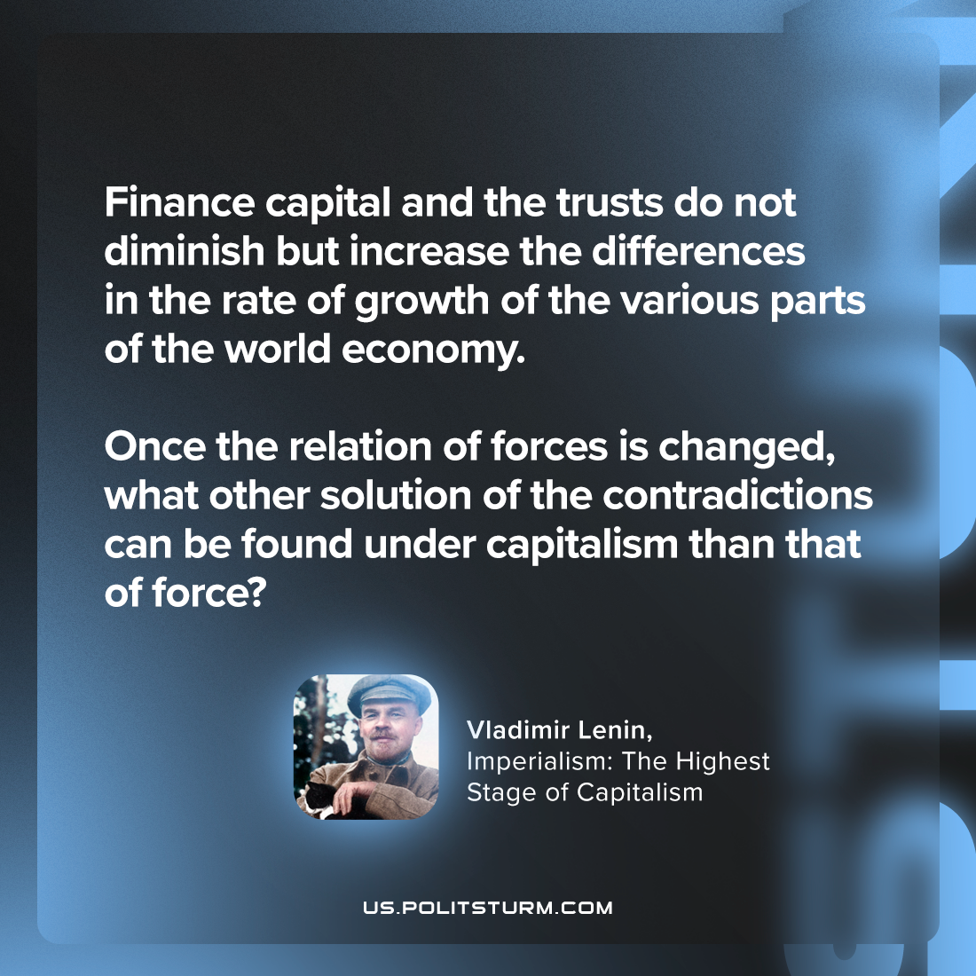

Original article
2023-11-28

"Finance capital and the trusts do not diminish but increase the differences in the rate of growth of the various parts of the world economy. Once the relation of forces is changed, what other solution of the contradictions can be found under capitalism than that of force?"
Vladimir Lenin, Imperialism: the Highest Stage of Capitalism

Original article

