Lenin on the Context of War
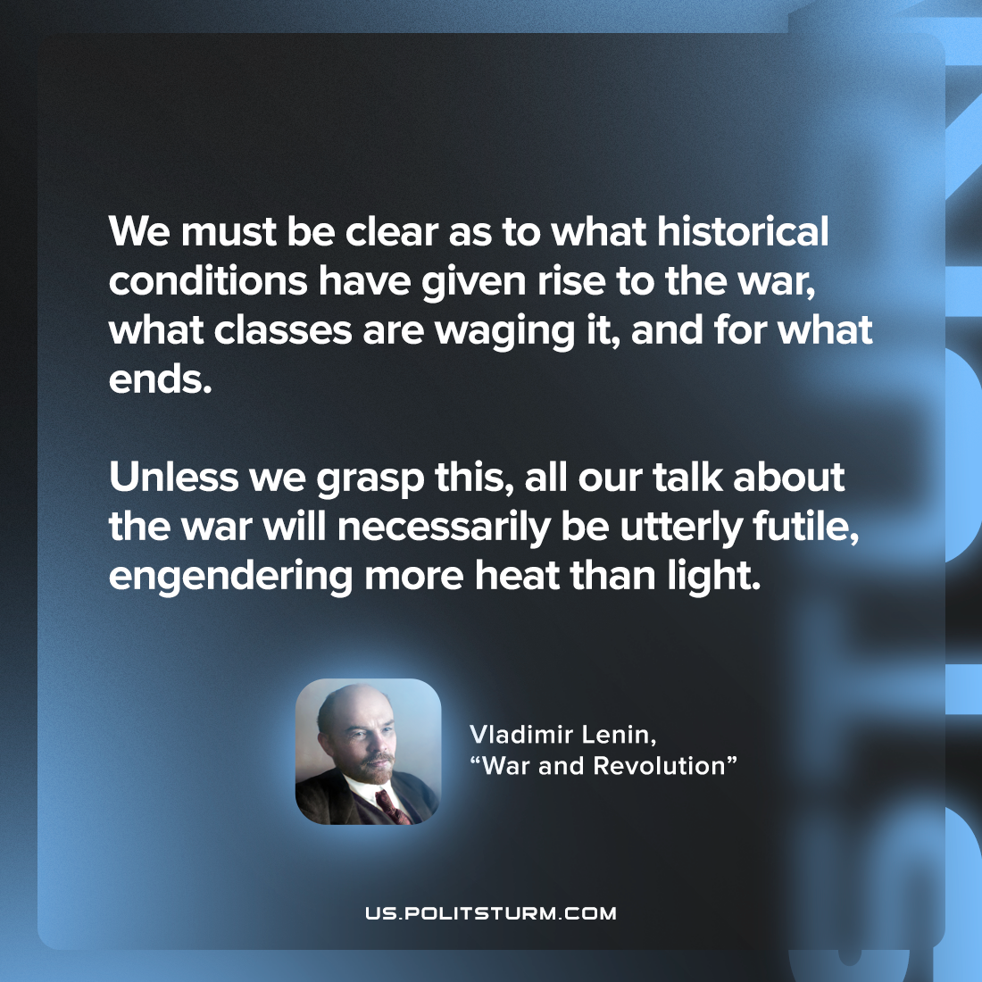

Original article
2022-09-02

We must be clear as to what historical conditions have given rise to the war, what classes are waging it, and for what ends. Unless we grasp this, all our talk about the war will necessarily be utterly futile, engendering more heat than light.

Vladimir Lenin, “War and Revolution”

Original article

