Lenin on The Classes
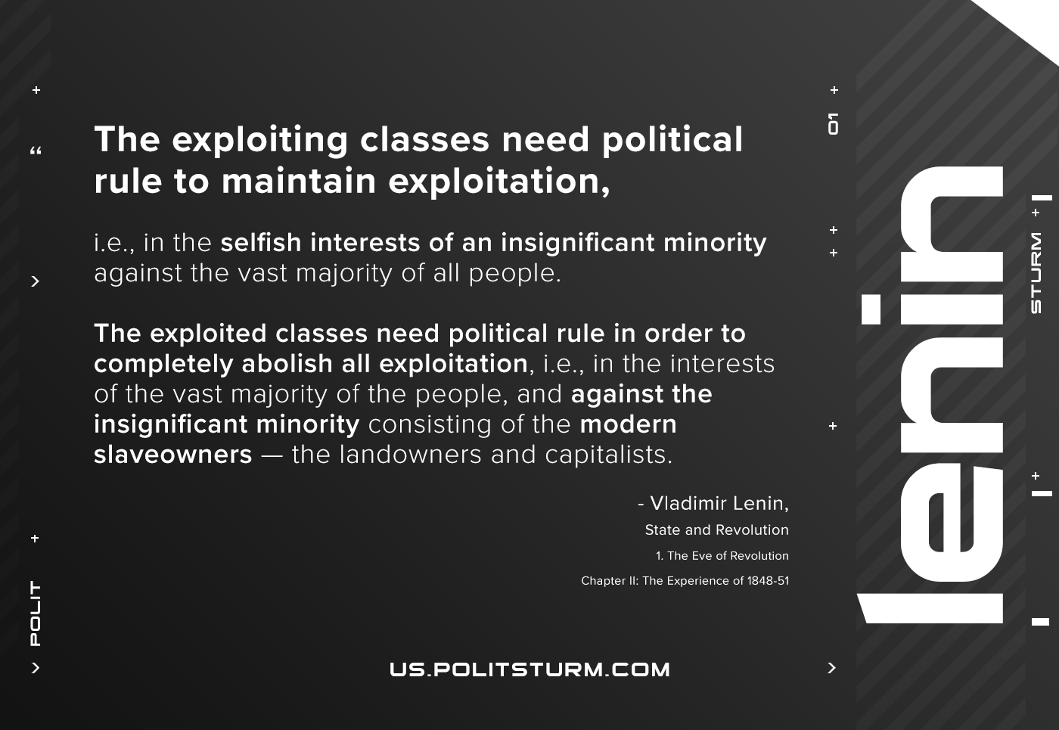

Original article
2020-12-14

The exploiting classes need political rule to maintain exploitation, i.e., in the selfish interests of an insignificant minority against the vast majority of all people. The exploited classes need political rule in order to completely abolish all exploitation, i.e., in the interests of the vast majority of the people, and against the insignificant minority consisting of the modern slave­owners — the landowners and capitalists.
Vladimir Lenin, The State and Revolution

Original article

