Lenin on the Class Struggle
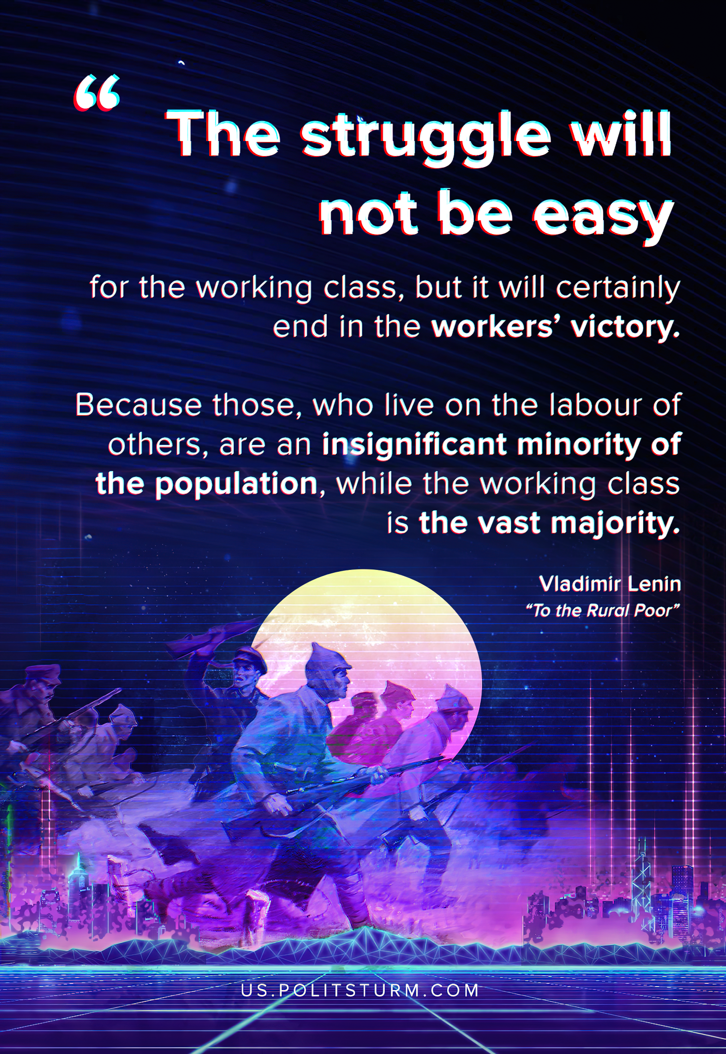

Original article
2020-03-17

The struggle will not be easy for the working class, but it will certainly end in the workers’ victory because the bourgeoisie, or those who live on the labour of others, are an insignificant minority of the population, while the working class is the vast majority. The workers against the property-owners means millions against thousands.
Vladimir Lenin, “To the Rural Poor”

Original article

