Lenin on the Class Role of Morality
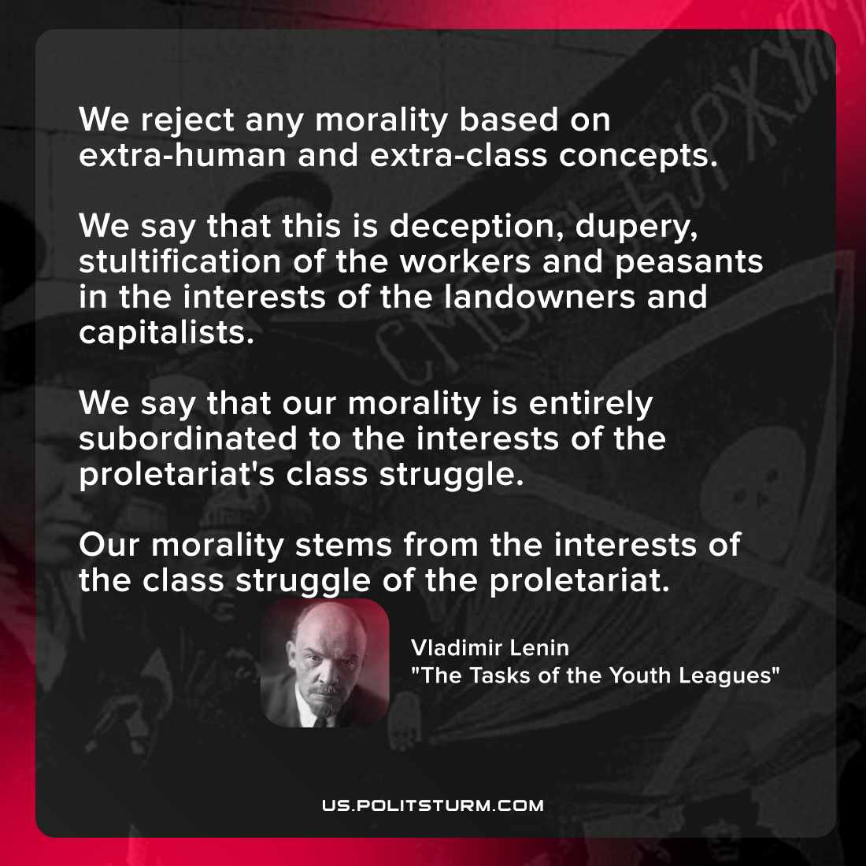

Original article
2022-03-08

We reject any morality based on extra-human and extra-class concepts. We say that this is deception, dupery, stultification of the workers and peasants in the interests of the landowners and capitalists.
We say that our morality is entirely subordinated to the interests of the proletariat’s class struggle. Our morality stems from the interests of the class struggle of the proletariat.

Vladimir Lenin, “The Tasks of the Youth Leagues”

Original article

