Lenin on the Basis Which Reactionary Classes Work
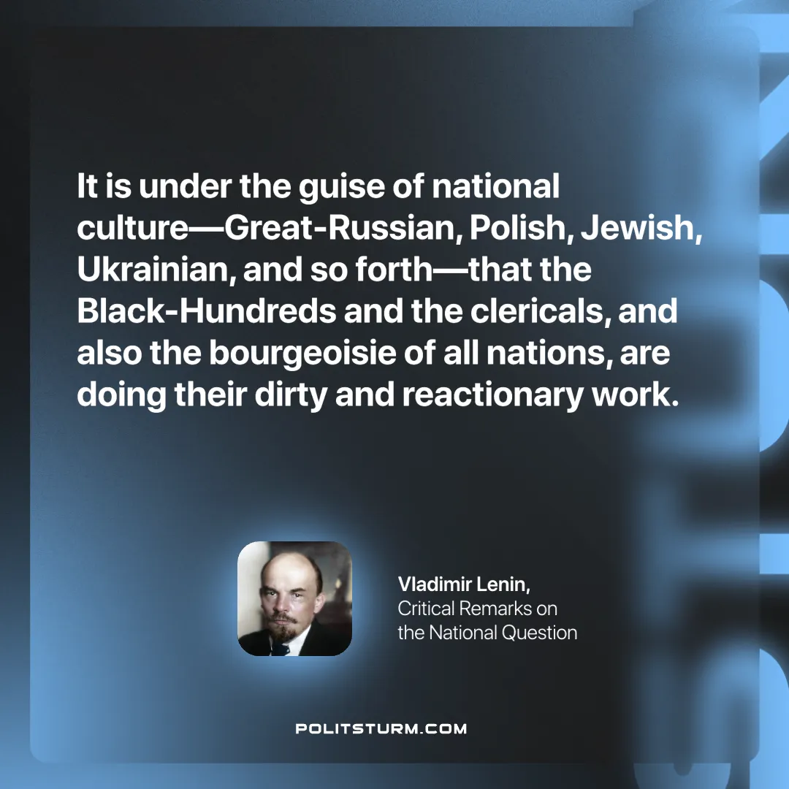

Original article
2024-10-17

“It is under the guise of national culture—Great-Russian, Polish, Jewish, Ukrainian, and so forth—that the Black-Hundreds and the clericals, and also the bourgeoisie of all nations, are doing their dirty and reactionary work.”
Vladimir Lenin, Critical Remarks on the National Question

Original article

