Lenin on The American people
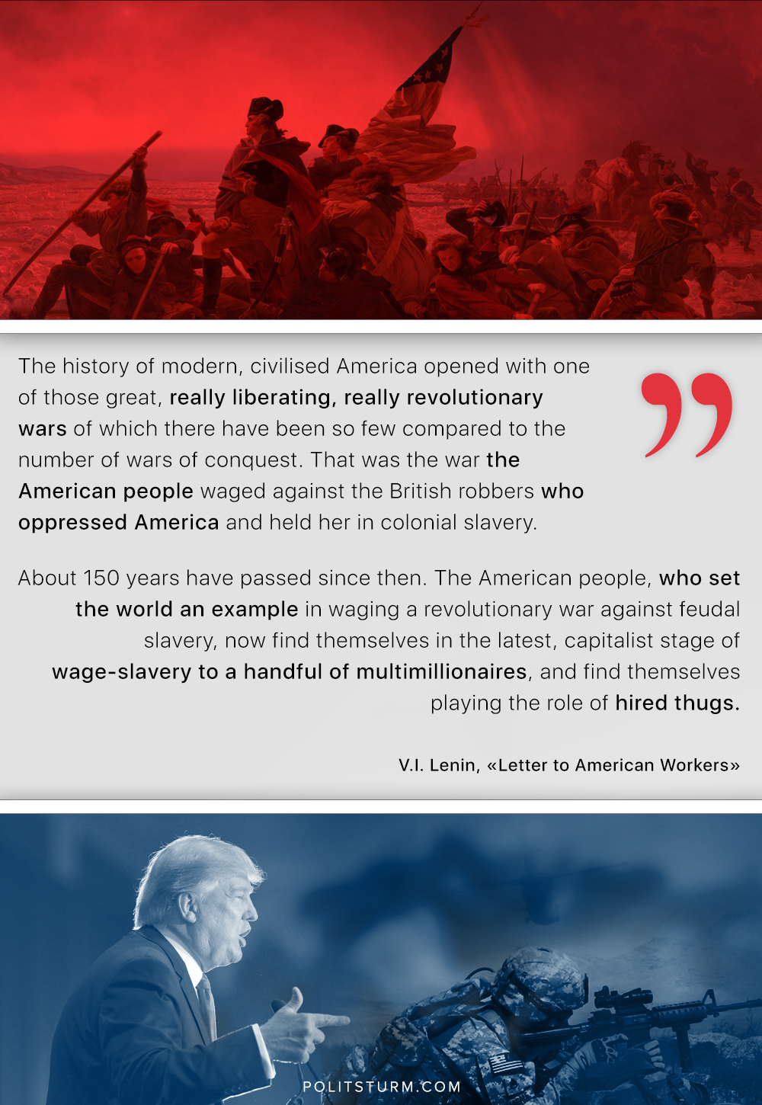

Original article
2018-07-04
1 min read

“The history of modern, civilised America opened with one of those great, really liberating, really revolutionary wars of which there have been so few compared to the vast number of wars of conquest. That was the war the American people waged against the British robbers who oppressed America and held her in colonial slavery…
About 150 years have passed since then. The American people, who set the world an example in waging a revolutionary war against feudal slavery, now find themselves in the latest, capitalist stage of wage-slavery to a handful of multimillionaires, and find themselves playing the role of hired thugs…”
V.I. Lenin, “Letter to American Workers”.

Original article

