Lenin on the Age of Finance Capital and "American Ethics"
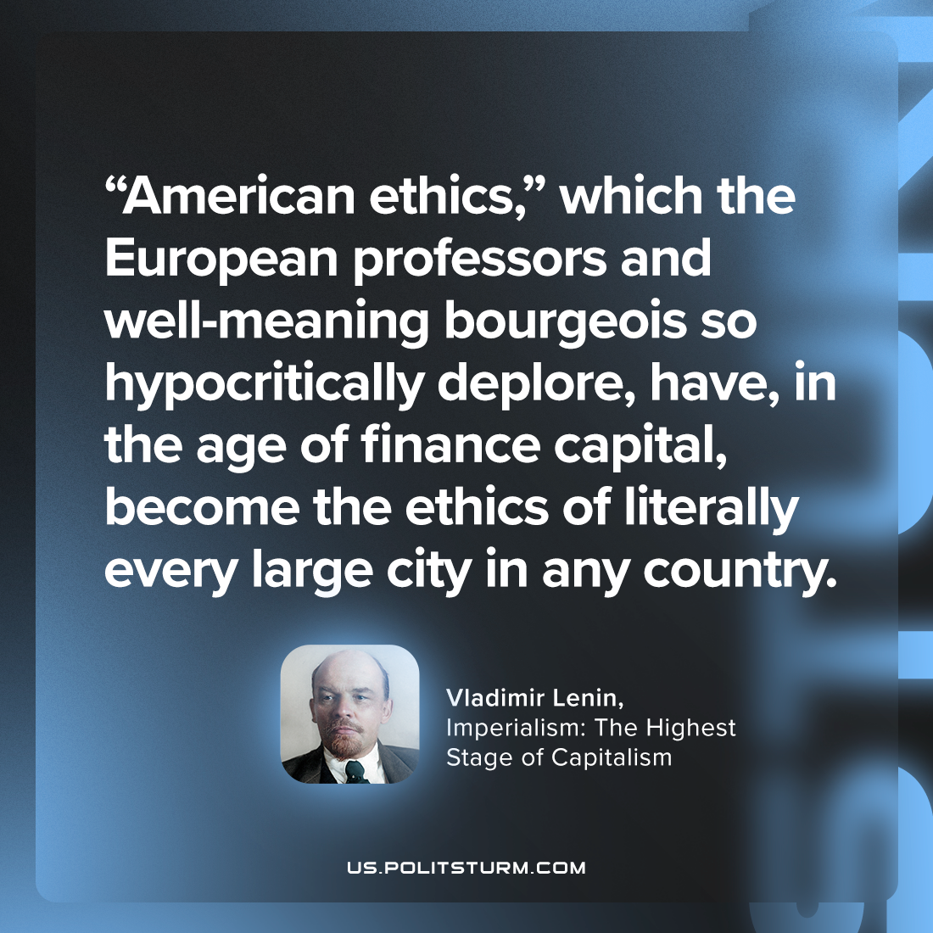

Original article
2023-10-01

"“American ethics,” which the European professors and well-meaning bourgeois so hypocritically deplore, have, in the age of finance capital, become the ethics of literally every large city in any country."
Vladimir Lenin, Imperialism: the Highest Stage of Capitalism

Original article

