Lenin on the Abolition of the Church
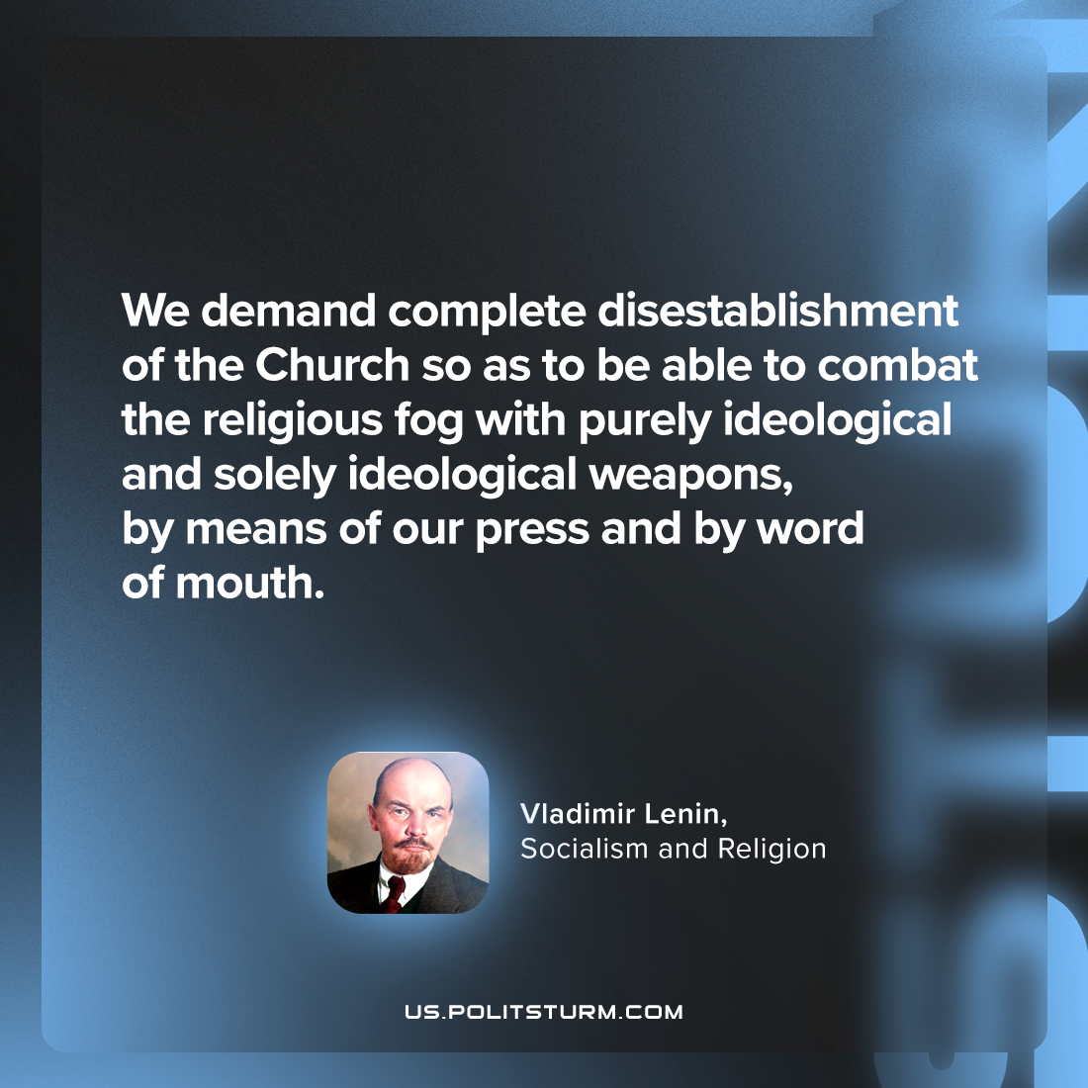

Original article
2024-05-05

“We demand complete disestablishment of the Church so as to be able to combat the religious fog with purely ideological and solely ideological weapons, by means of our press and by word of mouth.”
Vladimir Lenin, Socialism and Religion

Original article

