Lenin on the Abolition of Classes
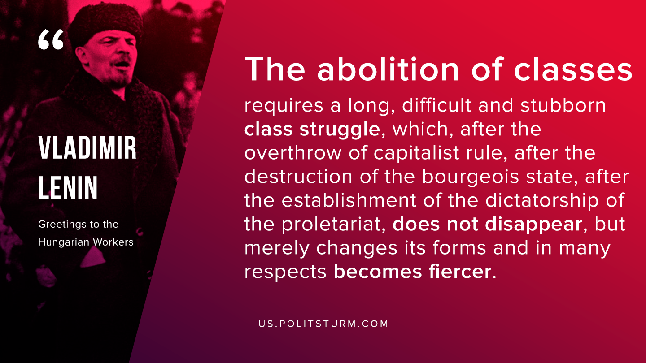

Original article
2019-11-14

The abolition of classes requires a long, difficult and stubborn class struggle, which, after the overthrow of capitalist rule, after the destruction of the bourgeois state, after the establishment of the dictatorship of the proletariat, does not disappear, but merely changes its forms and in many respects becomes fiercer.
V.I. Lenin “Greetings to the Hungarian Workers”

Original article

