Lenin on Struggle
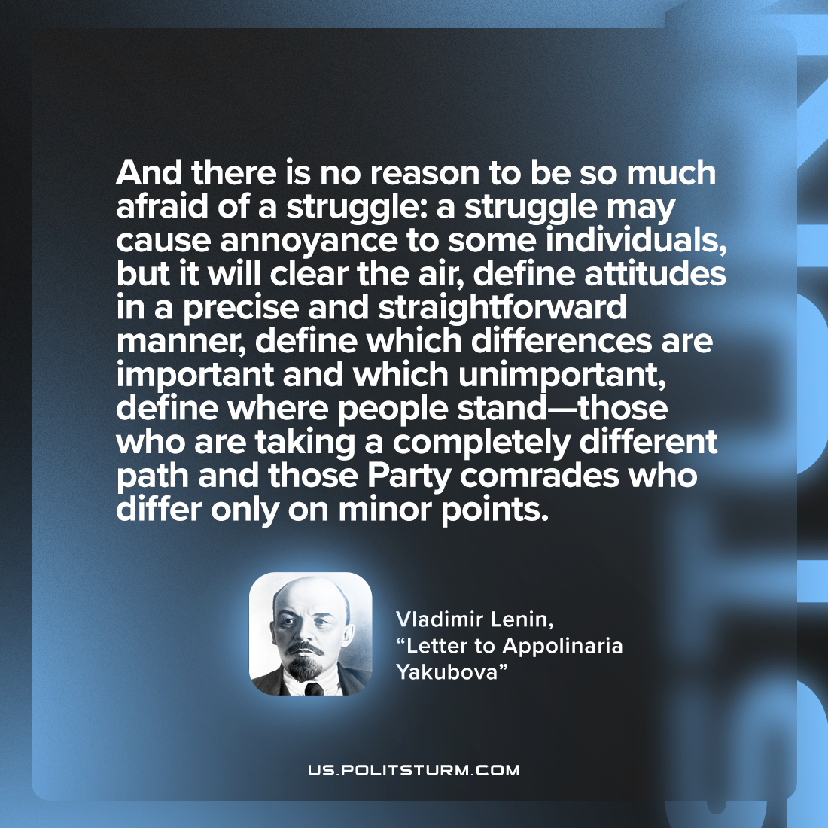

Original article
2023-02-07

"And there is no reason to be so much afraid of a struggle: a struggle may cause annoyance to some individuals, but it will clear the air, define attitudes in a precise and straightforward manner, define which differences are important and which unimportant, define where people stand—those who are taking a completely different path and those Party comrades who differ only on minor points."
Vladimir Lenin, “Letter to Appolinaria Yakubova”

Original article

