Lenin on Strikes
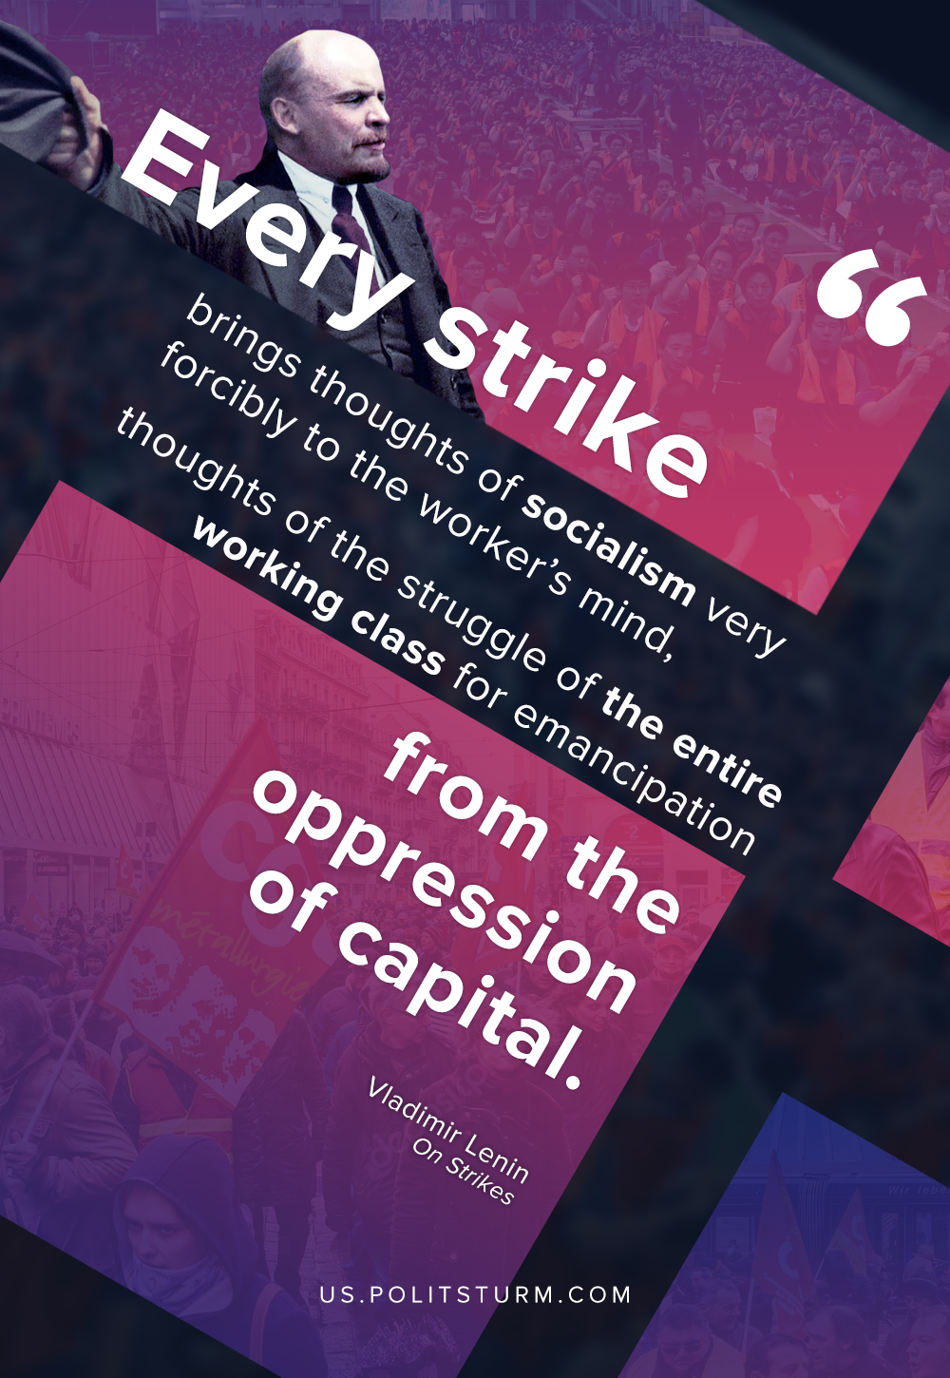

Original article
2020-12-28

Every strike brings thoughts of socialism very forcibly to the worker’s mind, thoughts of the struggle of the entire working class for emancipation from the oppression of capital.
Vladimir Lenin, On Strikes.

Original article

