Lenin on State
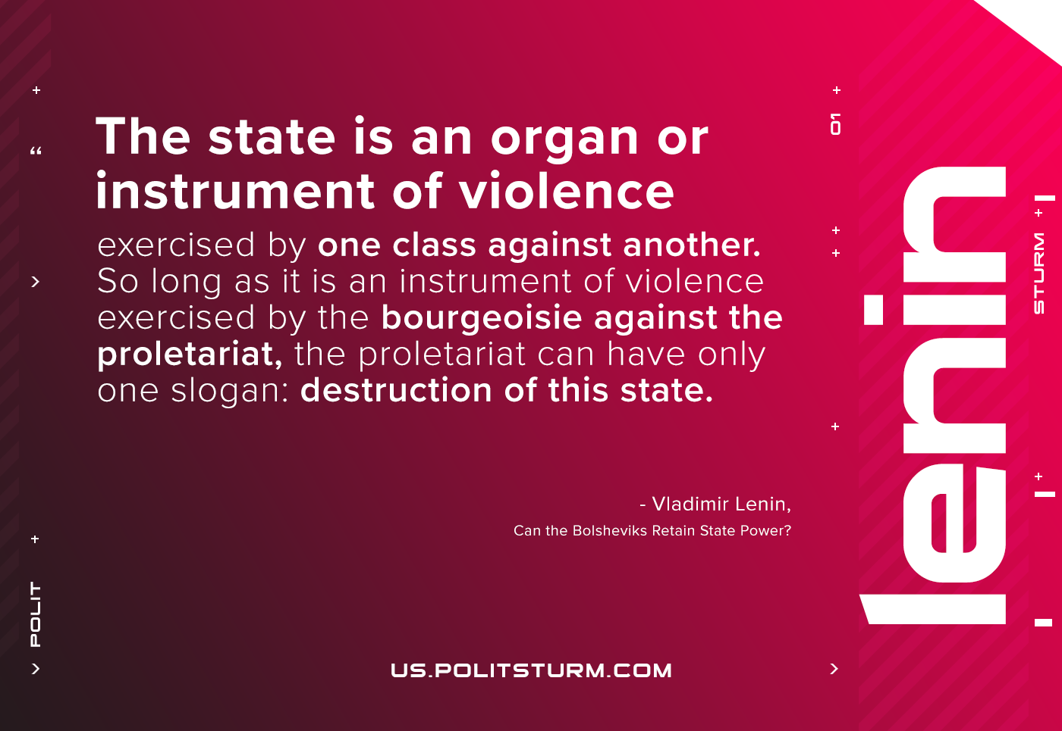

Original article
2021-01-17

The state is an organ or instrument of violence exercised by one class against another. So long as it is an instrument of violence exercised by the bourgeoisie against the proletariat, the proletariat can have only one slogan: destruction of this state.
Vladimir Lenin, “Can the Bolsheviks Retain State Power?”

Original article

