Lenin on State
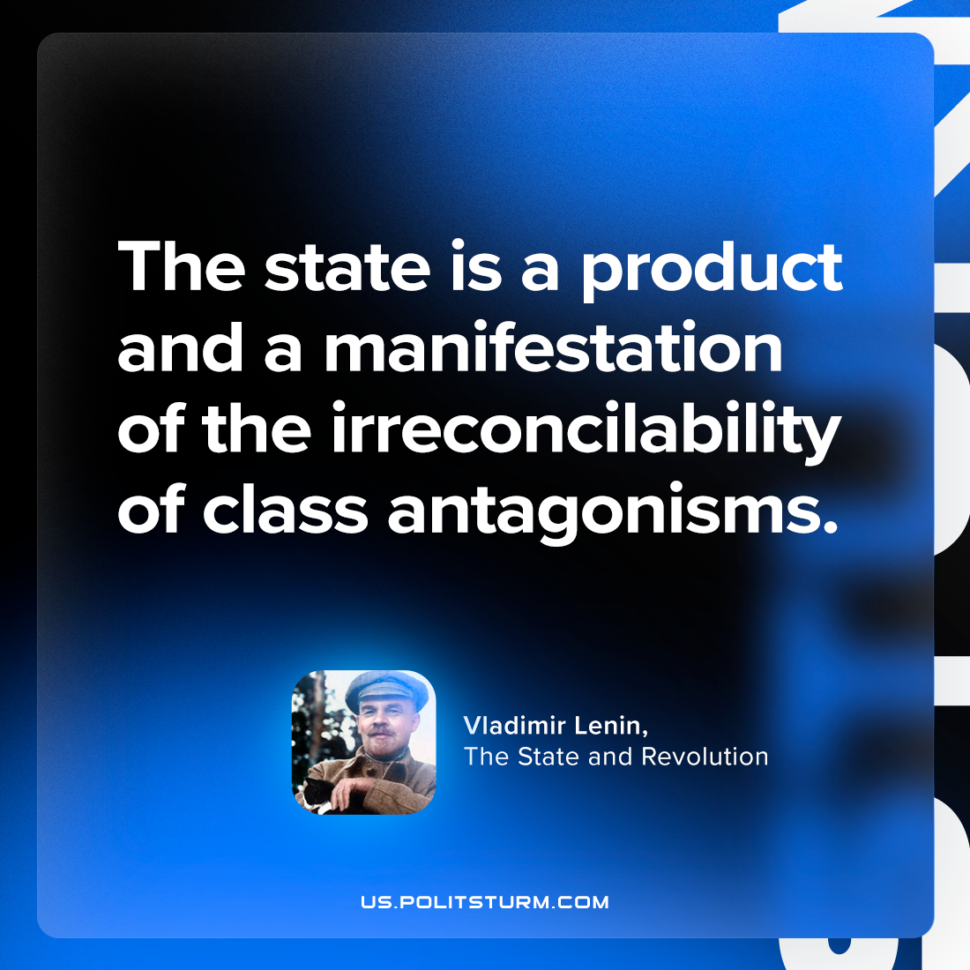

Original article
2024-01-04

"The state is a product and a manifestation of the irreconcilability of class antagonisms."
Vladimir Lenin, The State and Revolution

Original article

