Lenin on Socialist Revolution
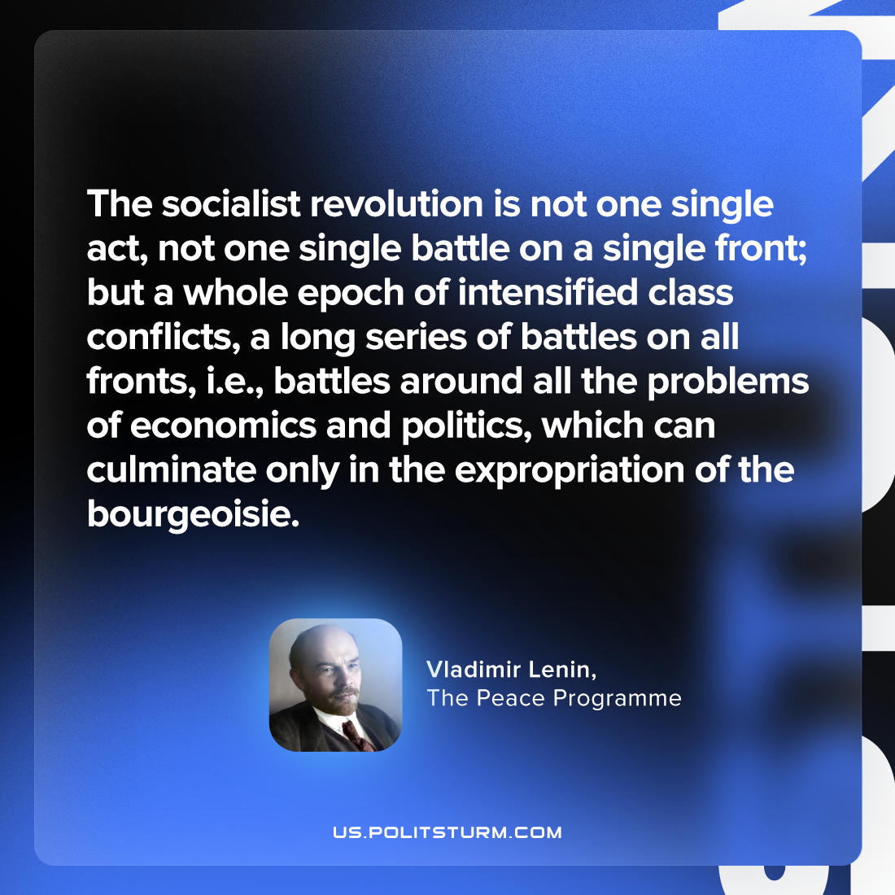

Original article
2023-07-09

"The socialist revolution is not one single act, not one single battle on a single front; but a whole epoch of intensified class conflicts, a long series of battles on all fronts, i.e., battles around all the problems of economics and politics, which can culminate only in the expropriation of the bourgeoisie."
Vladimir Lenin, The Peace Programme

Original article

