Lenin on Socialism
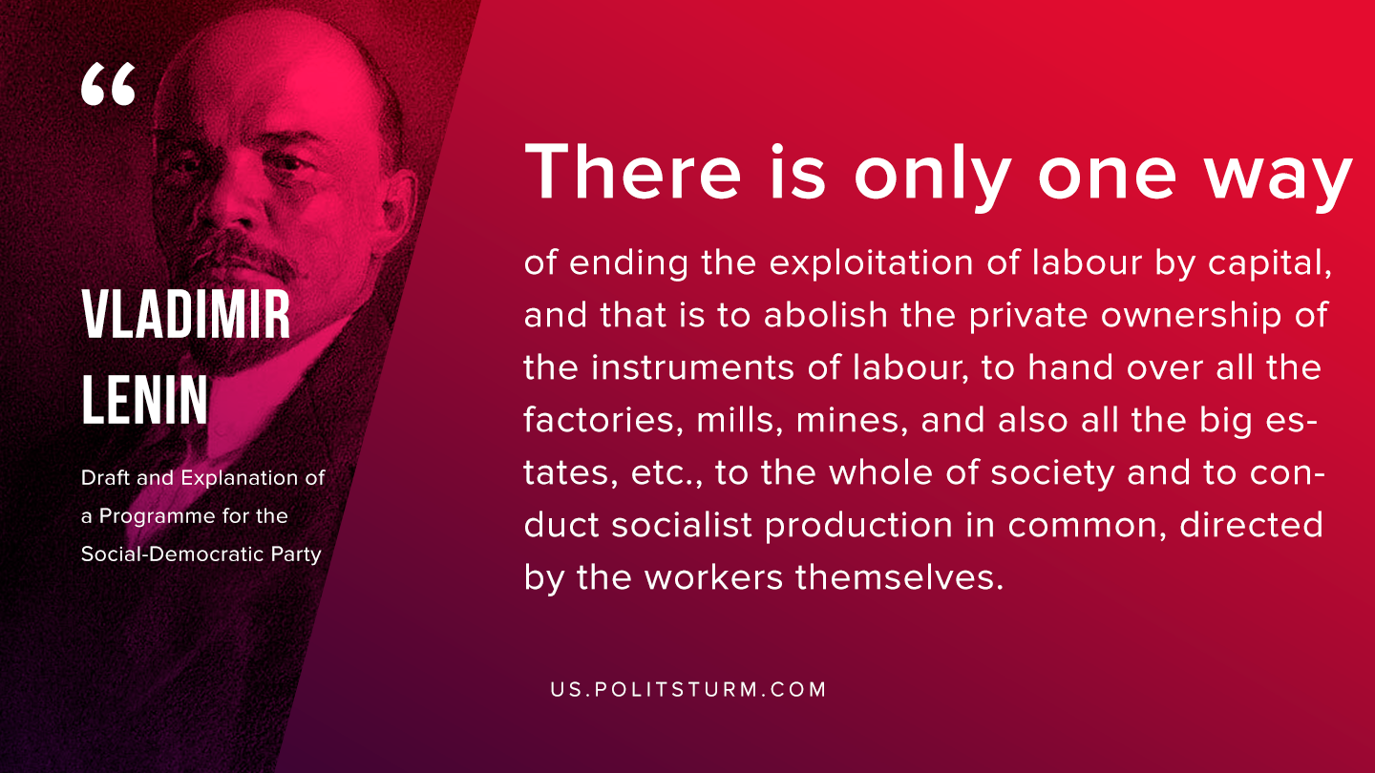

Original article
2019-11-12

There is only one way of ending the exploitation of labour by capital, and that is to abolish the private ownership of the instruments of labour, to hand over all the factories, mills, mines, and also all the big estates, etc., to the whole of society and to conduct socialist production in common, directed by the workers themselves.
V.I. Lenin, “Draft and Explanation of a Programme for the Social-Democratic Party”

Original article

