Lenin on Socialism or Suffering
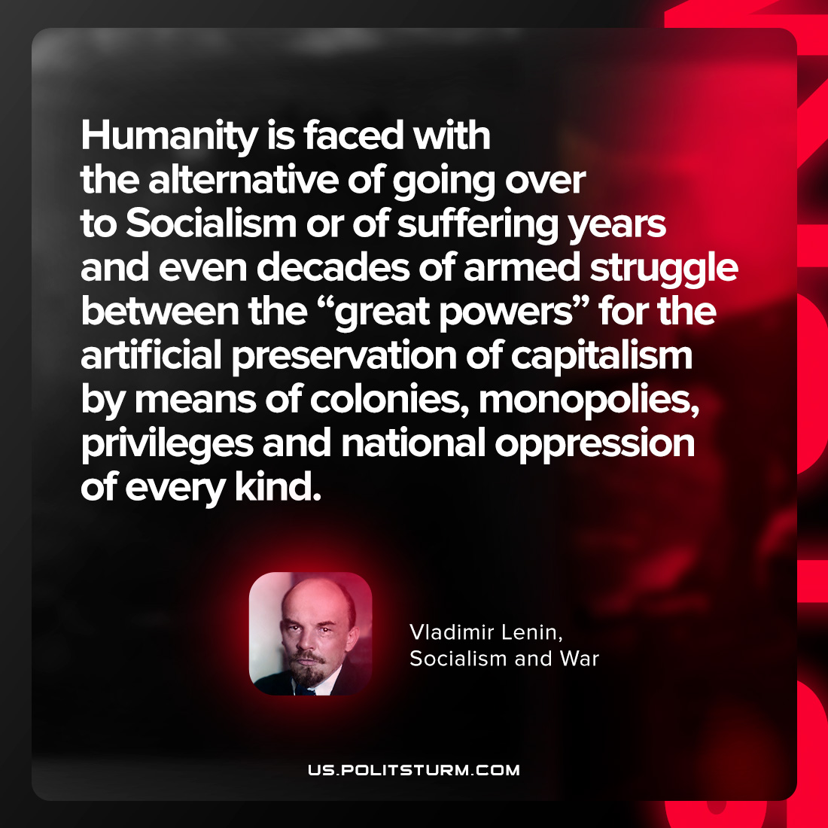

Original article
2022-03-07

Humanity is faced with the alternative of going over to Socialism or of suffering years and even decades of armed struggle between the “great powers for the artificial preservation of capitalism by means of colonies, monopolies, privileges and national oppression of every kind.

Vladimir Lenin, “Socialism and War”

Original article

