Lenin on Social Democracy According to Engels
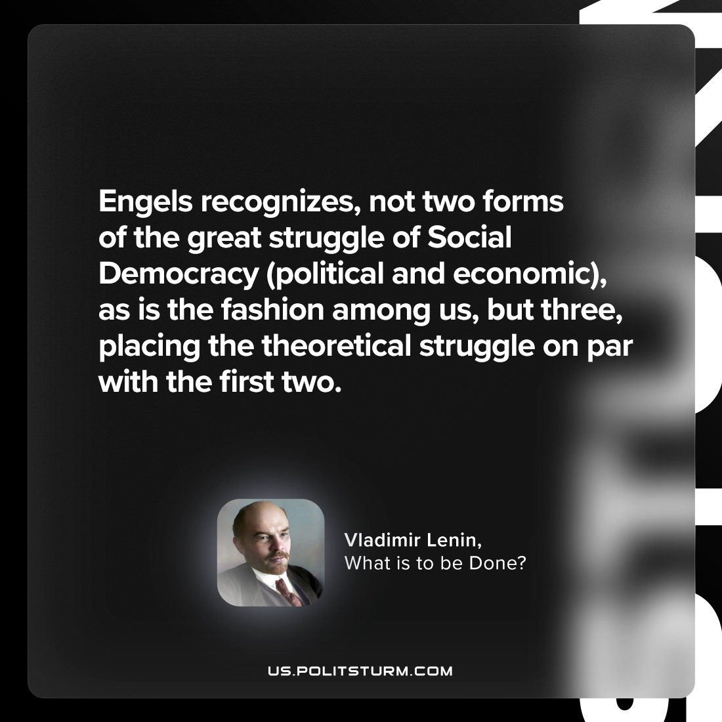

Original article
2024-02-08

"Engels recognizes, not two forms of the great struggle of Social Democracy (political and economic), as is the fashion among us, but three, placing the theoretical struggle on par with the first two."
Vladimir Lenin, What Is To Be Done?

Original article

